**D212 Task 1: Clustering Techniques**

**Joseph Duszynski**

**ID #011237236**

**A.1. Proposal of question**

Using the provided medical dataset (WGU, 2024 [1]), this project seeks to answer the following question: “Can a *k*-means clustering model partition the patients in a relevant, meaningful way from their available numerical demographic and health data? Which variables are most and least relevant in these clusters?”

**A.2. Defined goal**

This project aims to find meaningful clusters of patients that can be used for future analytic goals such as dimension reduction and possible insights into health-related patterns and trends affecting patients. For example, there may be a cluster of patients in a certain income bracket and age range with a previously unknown incidence of a health condition significantly different from the overall population rate. Discovering that relationship can assist with prevention, treatment, outreach, and additional research. Additionally, if a feature is found to have very similar coordinate values across all clusters’ centroids, it might be considered for removal in later dimension reduction after being verified as largely irrelevant.

**B.1. Explanation of the clustering technique**

*k*-means clustering is an unsupervised learning algorithm that seeks to partition the observations of a dataset into *k* clusters, with *k* being specified beforehand. Ideally, the algorithm finds the *k* sets of points that minimize the within cluster variance (in terms of sum of squares of differences between the data points and the centroid (mean) of their assigned cluster), also referred to as WCSS.

In practice, it finds a sufficient approximation through an iteration process seeking convergence that keeps WCSS as small as it can, as testing over all possible $k^{n}$ configurations of *k* sets is extraordinarily expensive even for *k* = 2.

The algorithm assigns an initial set of *k* centroids as locations of the cluster centers, either randomly or through another procedure. Each point in the dataset is then assigned to its nearest cluster (i.e. centroid) on the basis of a specified distance metric, generally Euclidean. Following the assignment of all points, the centroids are recalculated as the means of the points within each cluster. If the updated centroids agree with the previous centroids used before assigning points to clusters, the algorithm terminates and returns the clusters with their centroids. If they do not agree, the updated centroid coordinates are used to repeat the stage of the algorithm that assigns data points to their nearest cluster. After cluster assignment, the centroids are once again recalculated and compared to the previous set of centroids. This process continues until the centroids converge to an equilibrium (Sharma, 2024 [1]).

**B.2. Summary of the technique assumption**

As discussed in the previous section, *k*-means minimizes the variance within clusters, which inherently favors spherical clusters with radii as small as possible. If the desired, or in some sense objective (e.g. comparing the algorithm’s clusters with known labels such as species) clusters have irregular, non-spherical shapes, the algorithm may assign them to incorrect (or undesirable) clusters, as it seeks to find the nearest centroid to each point. Naturally, computing distances requires that the input data all be numerical.

*k*-means assumes the points within a cluster are relatively similar in that the intra-cluster distances between them are sufficiently small. In contrast, the distances between cluster centroids should be larger relative to the diameters of the clusters. In this way, the clusters can be regarded as sets of similar points that are considerably distinct from points in other clusters. If there is considerable overlap between clusters, the assignment of the algorithm is imprecise and unstable, as the points in such an intersection could plausibly be assigned to any cluster that region in an arbitrary way (Sharma, 2024 [1]).

Although in theory extensive modifications and weights could be used in a distance metric, most implementations of *k*-means use Euclidean distances or another metric that’s agnostic to a feature’s name and scale. Therefore, for the model to function as intended, it’s vital that each feature is scaled to have the same variance as other features. Otherwise, features of larger scales would dominate the distance calculations and render features of smaller scales invisible. The inclusion of a feature in the clustering assumes it has a relatively equal contribution to the distance metric as every other included feature.

To appropriately converge in an efficient number of iterations, the initial choice of centroids must be sufficiently far apart from one another. Overlapping centroid locations makes the assignment of the involved points unstable from one iteration to the next and will be slow to converge.

**B.3. Packages or libraries list**

I chose Python 3.9 for its ease of use, widespread adoption, personal familiarity, speed, multitude of mathematical and statistical packages, and extensive documentation and examples online for debugging and understanding. I prefer the consistent syntax of Python and its packages compared to libraries in R. Additionally, I wrote data cleaning functions in Python for the D206 course, making it convenient to repurpose that work here.

Numpy and pandas were used for handling numerical computations on arrays and dataframes, respectively. They’re effectively mandatory for any of the project to work. Matplotlib and seaborn were needed to produce histograms and scatterplots. Scipy.stats was required for calculating z-scores to be used in creating z-score histograms for outlier searching. From scikit-learn, KMeans() was used to create the k-means cluster model, silhouette_score was needed to calculate the silhouette scores for evaluating the models, and StandardScaler() was required to appropriately scale the features and ensure equal variance. MinMaxScaler() and RobustScaler() were used for testing purposes.

import numpy as np  
import pandas as pd  
import matplotlib.pyplot as plt  
from scipy import stats  
import seaborn as sns  
from sklearn.metrics import silhouette_score  
from sklearn.preprocessing import StandardScaler, MinMaxScaler, RobustScaler  
from sklearn.cluster import KMeans

**C.1. Data preprocessing**

In addition to the usual steps of data cleaning such as handling null values, addressing outliers, and verifying there are no duplicates, the initial exploratory *k*-means cluster models require one-hot encoding to utilize categorical variables as input, as they use numerical data when calculating distances between points.

This is accomplished through the function one_hot_encoder which creates dummy variables (through pandas.get_dummies(df[column])), converts the Boolean values to 32-bit integers (1s and 0s), and creates a new column of the form ‘{column_name}_{column_label}’. For instance, a binary categorical variable like ‘Stroke’ introduces the column ‘Stroke_Yes’. Binary categorical variables only require one encoded column to completely specify the presence or absence of a condition (i.e. the drop_first=True condition is used in get_dummies). For categorical variables with three or more classes, encoded columns are introduced for each class.

See below:

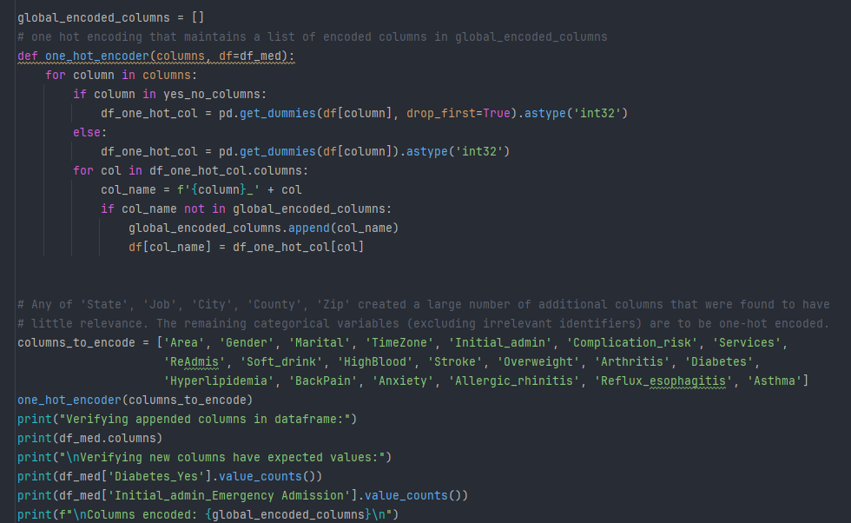

More importantly, the data must be scaled to have to equal variance across all features used in the models. This is accomplished with StandardScaler() in the function scale_data. See below:

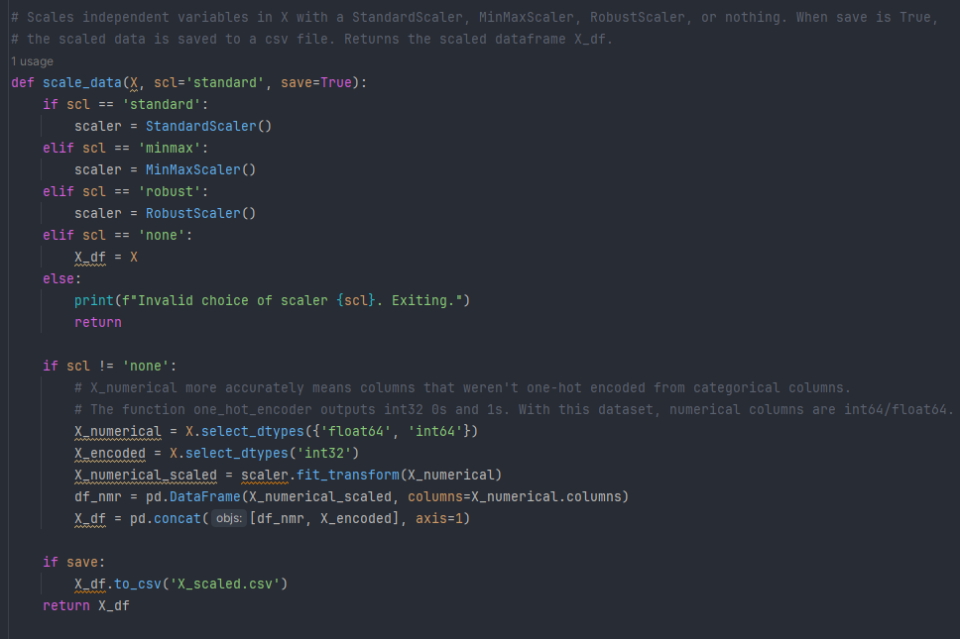

**C.2. Data set variables**

The following are the variables from the dataset [1] used at any point in building the model. Note that although there are issues with cluster interpretation in including one-hot encoded variables, they were used for exploratory purposes and ultimately discarded for the final model. In a different project, *k*-modes could be used to appropriately handle one-hot encoded categorical variables. Informally, cluster centroids with non-integer coordinates for one-hot encoded features could be viewed as the cluster’s population mean of having that condition (e.g. a coordinate of 0.25 for asthma incidence when values are only 1 or 0 imply 25% of the patients within that cluster have asthma). The project specifically requests only numerical data be used, so the initial models with encoded categorical variables are reduced accordingly.

Lat: numeric

Lng: numeric

Population: numeric

Children: numeric

Age: numeric

Income: numeric

ReAdmis_Yes: numeric (one-hot encoded categorical from ReAdmis)

VitD_levels: numeric

Doc_visits: numeric

TotalCharge: numeric

vitD_supp: numeric

Full_meals_eaten: numeric

Initial_admin_Observation Admission: numeric (one-hot encoded categorical from Initial_admin)

Complication_risk_Low: numeric (one-hot encoded categorical from Complication_risk)

Services_MRI: numeric (one-hot encoded categorical from Services)

Initial_days: numeric

Additional_charges: numeric

**C.3. Steps for analysis**

First, the dataset backs up integer ‘Zip’ values to a new column ‘Zip_int64’ then replaces the values in the ‘Zip’ column with categorical strings of five digits (i.e. leading 0s are restored). ‘CaseOrder’ is also converted to a string as it and ‘Zip’ are more accurately regarded as categorical data. A few simple commands verify there are no null values or duplicates.

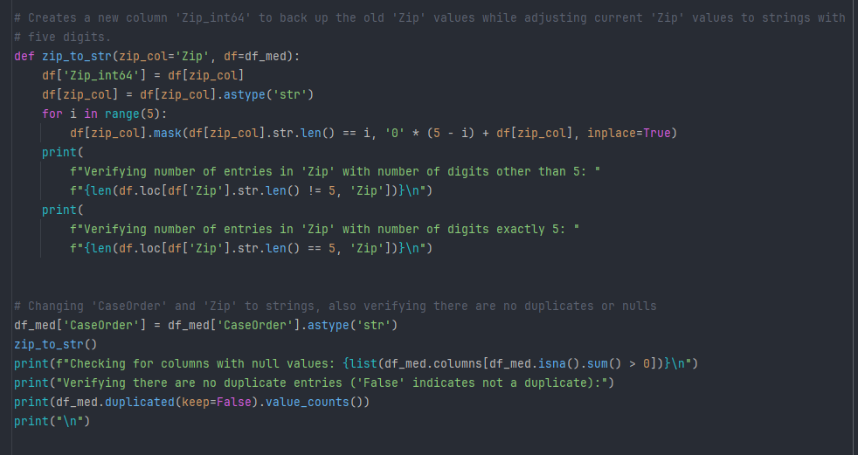

The functions inspect_data and outlier_search are used to verify no outliers distort the analysis and that column constraints are obeyed.

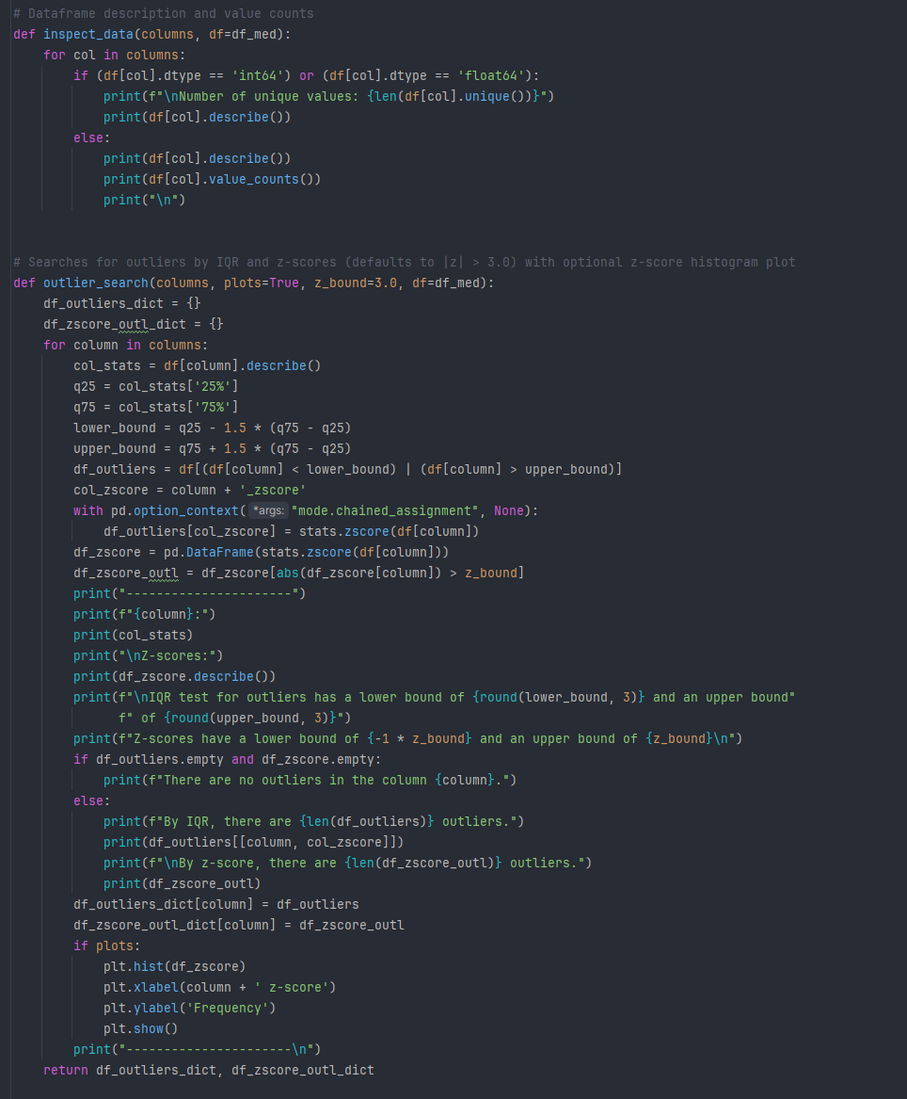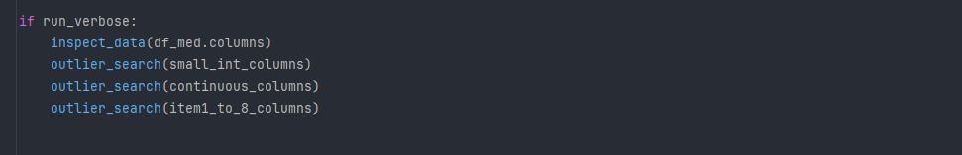

The function one_hot_encoder uses pandas.get_dummies to create binary numeric columns for the presence or absence of a given class for each categorical feature in columns_to_encode. drop_first=True is only used on the binary categorical columns (that record ‘Yes’/’No’ values). This is a necessary transformation step for (raw) categorical variables to be valid numerical input in a *k*-means clustering model.

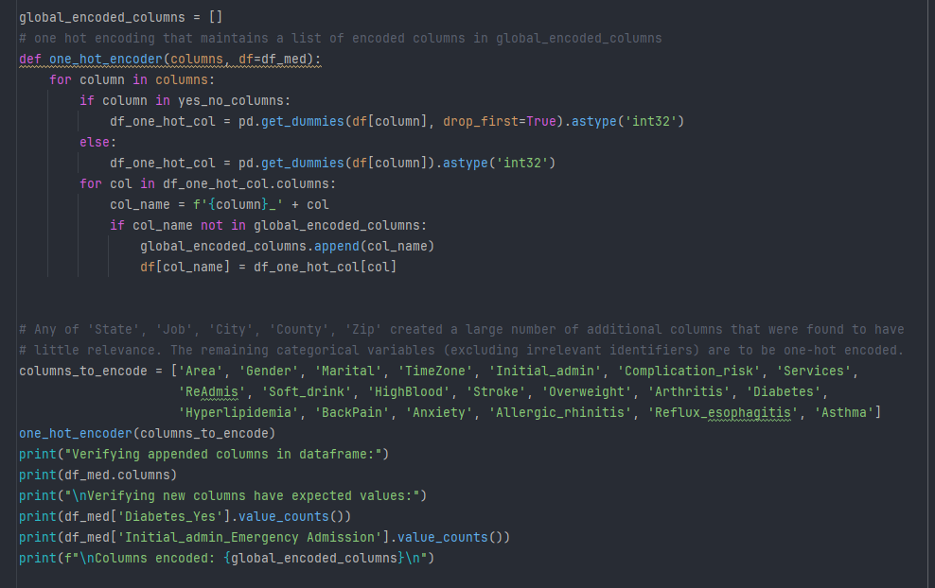

The data is scaled with StandardScaler() using the function scale_data.



**C.4. Cleaned data set**

For a dataset with outliers, duplicates, and null values addressed, as well as encoded columns, see “medical_cleaned_clustering.csv”. For a subset of that file including only the variables used in the model, see “medical_transformed_clustering.csv”. For the final scaled version of the cleaned and reduced dataset, see “X_scaled.csv”.

**D.1. Output and intermediate calculations**

After performing the preprocessing steps discussed in section C., functions were written to create *k*-means models on different sets of variables, evaluate them through their inertia and silhouette scores, and provide aggregate statistics on the clusters for selected features. These functions are provided in section D.2. with comments explaining their use and output. The first exploratory model was:

cluster_columns_0 = ['Initial_days', 'Age', 'Children', 'Income', 'Additional_charges', 'Population', 'ReAdmis_Yes', 'Complication_risk_Low', 'Services_MRI', 'Initial_admin_Observation Admission']

As explained in section C.2., although there are problems with interpretability of clusters on one-hot encoded variables, they were not used in the final model and were included to inspect what if any relevance they had within the clusters.

Output:

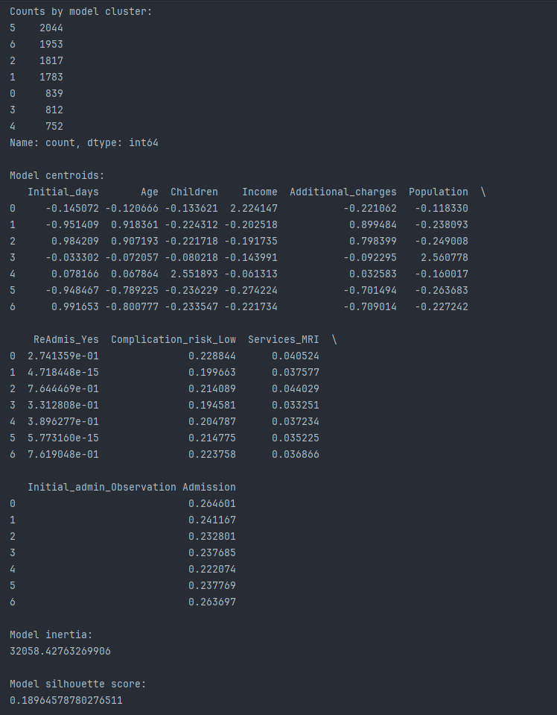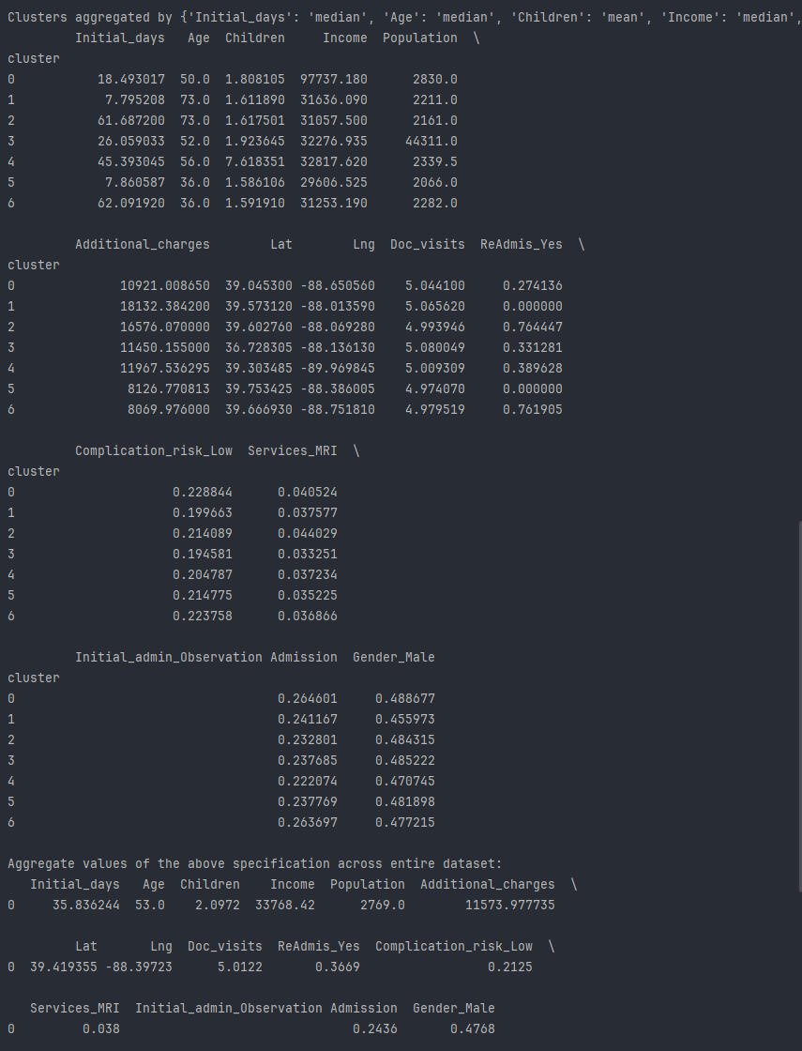

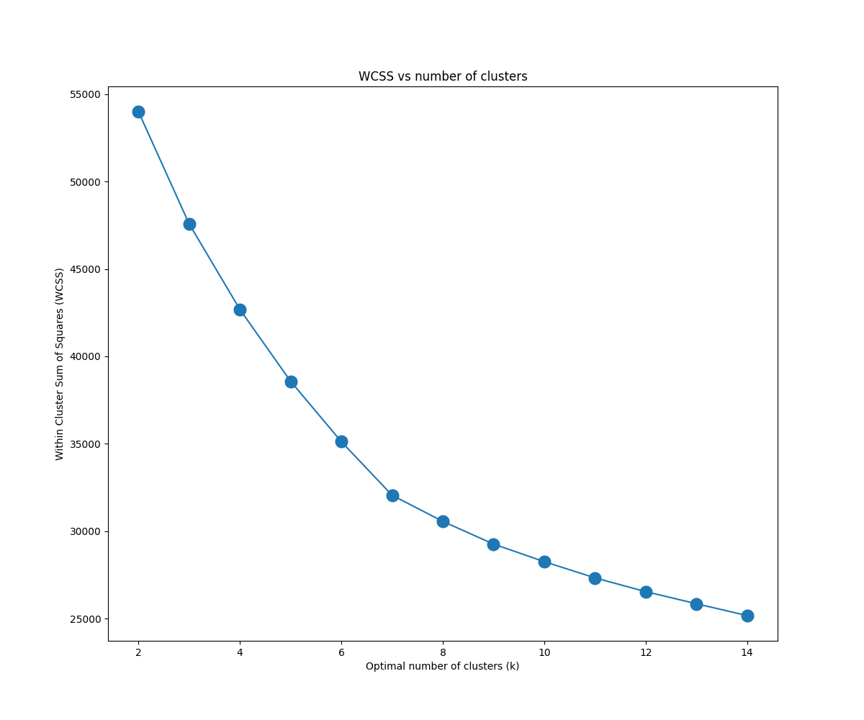

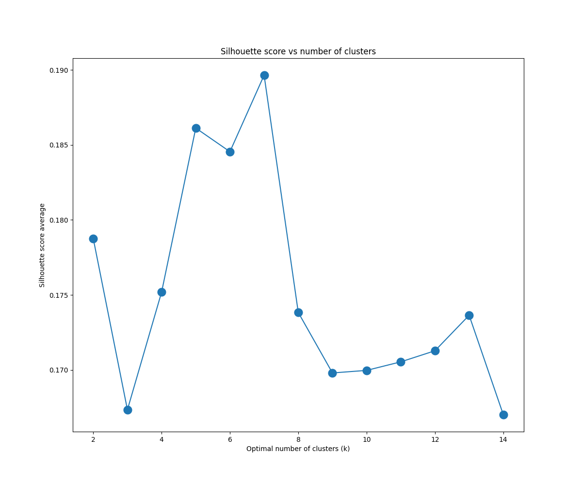

There are only small differences between centroid coordinates on the columns ‘Complication_risk_Low’, ‘Services_MRI’, and ‘Initial_admin_Observation Admission’. Further, those values are very similar to the aggregate means in the entire dataset. They’re virtually irrelevant in the clustering and should be removed. In contrast, ‘ReAdmis_Yes’ takes many different values and would be of interest in a different project using *k*-modes or an alternative clustering method. However, this project is confined to *k*-means so the encoded categorical variables ultimately can’t be used.

Next is a model using all thirteen of the numerical variables that weren’t survey questions:

cluster_columns_1 = ['Initial_days', 'Age', 'Children', 'Income', 'Additional_charges', 'Population', 'Lat', 'Lng', 'VitD_levels', 'TotalCharge', 'vitD_supp', 'Full_meals_eaten', 'Doc_visits']

Output:

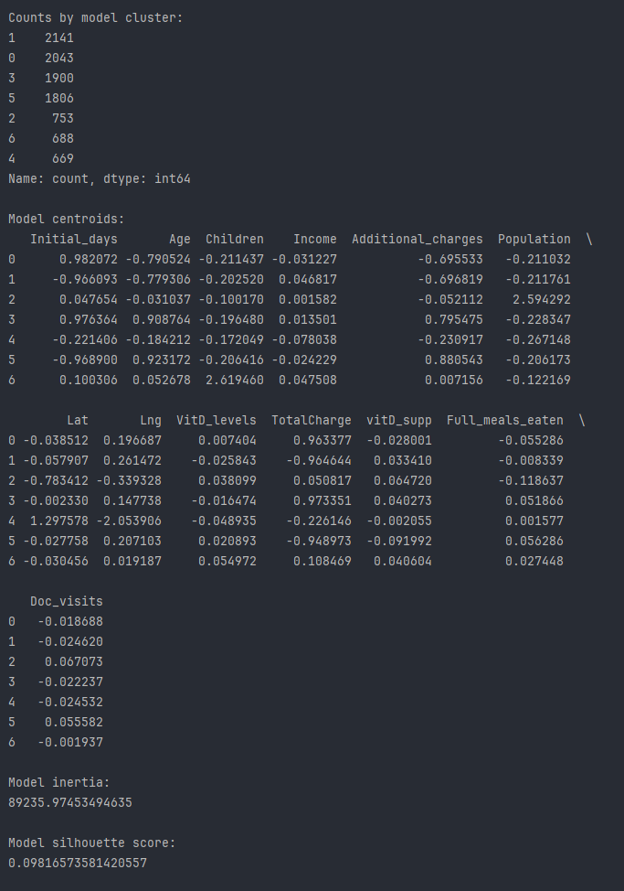

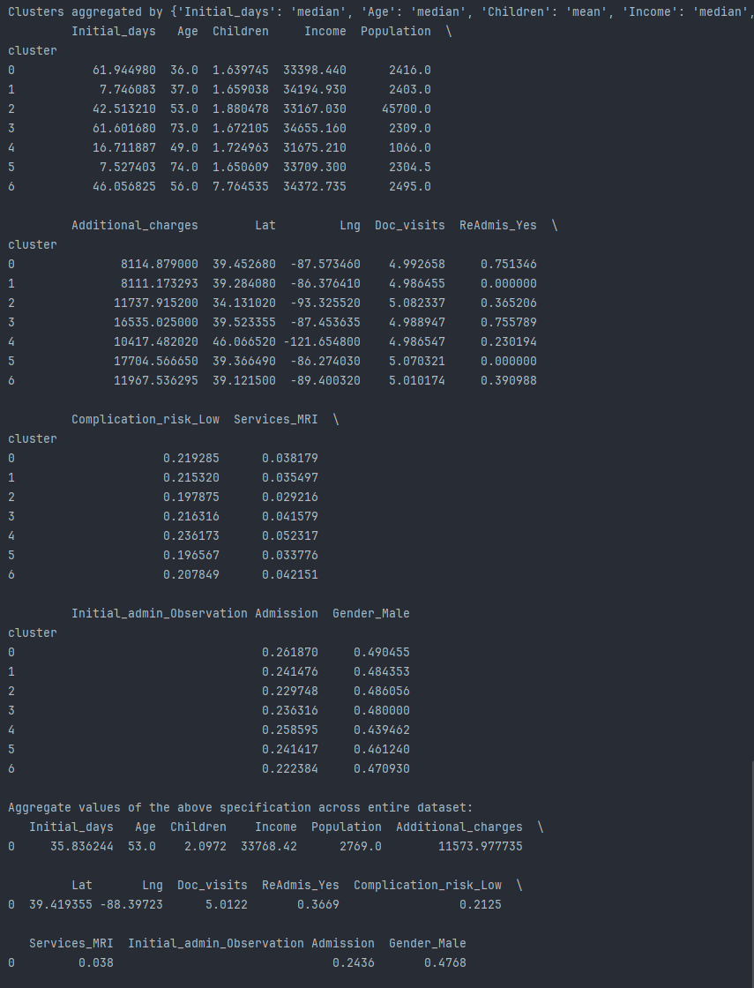

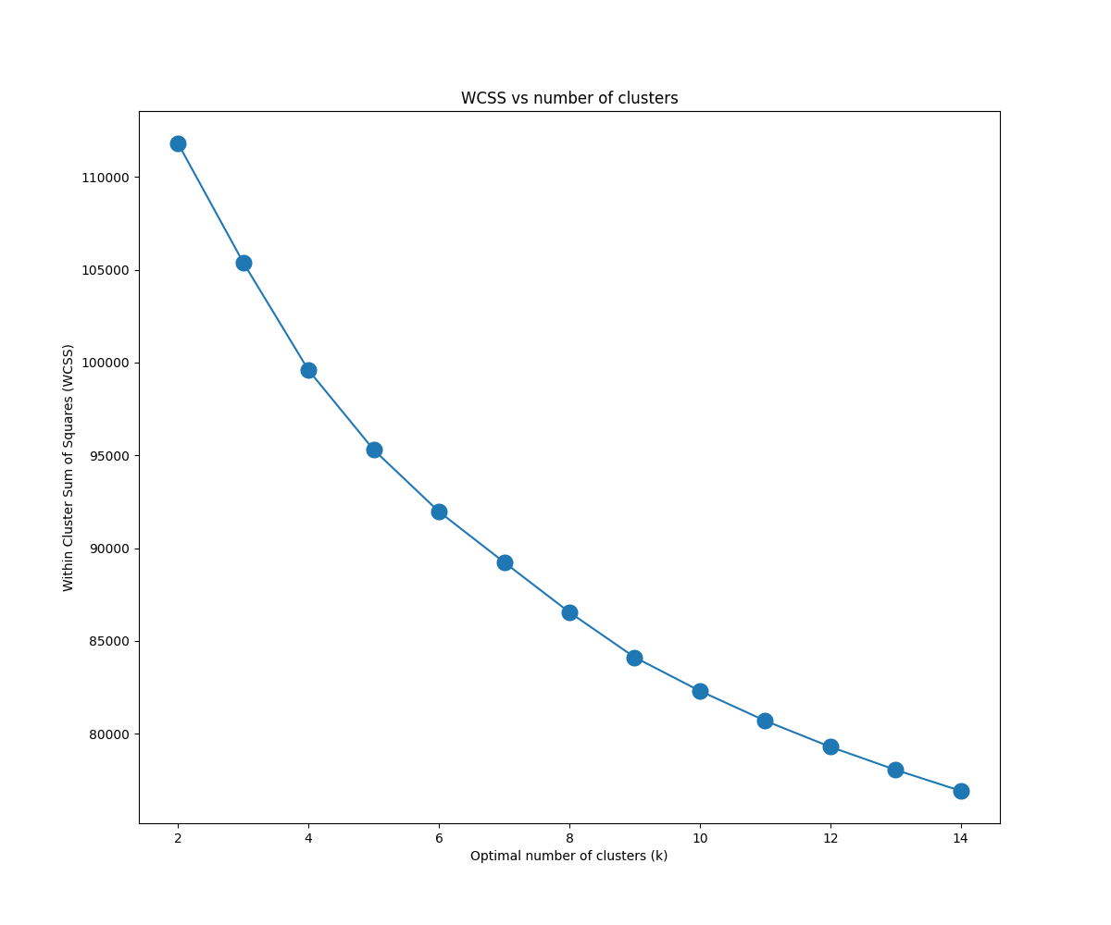

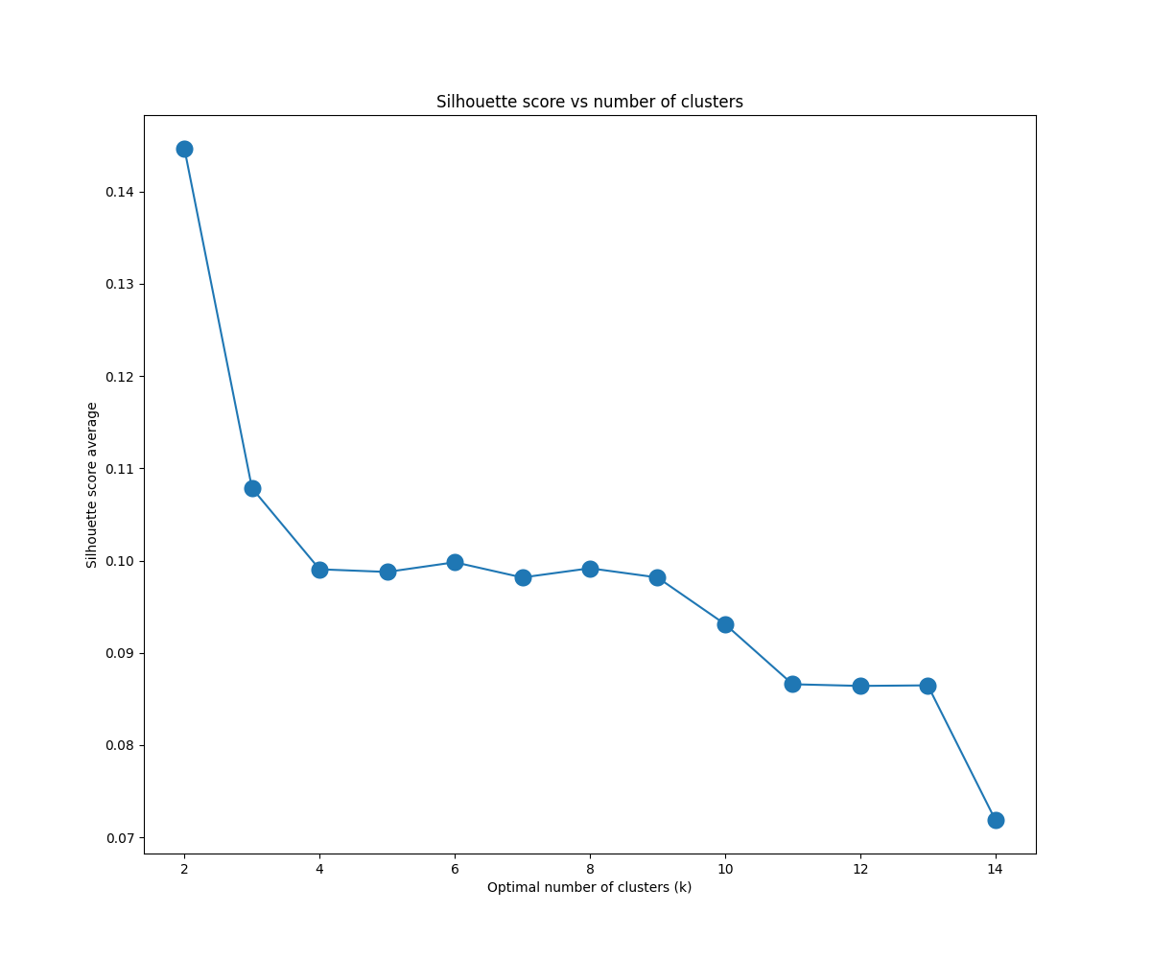

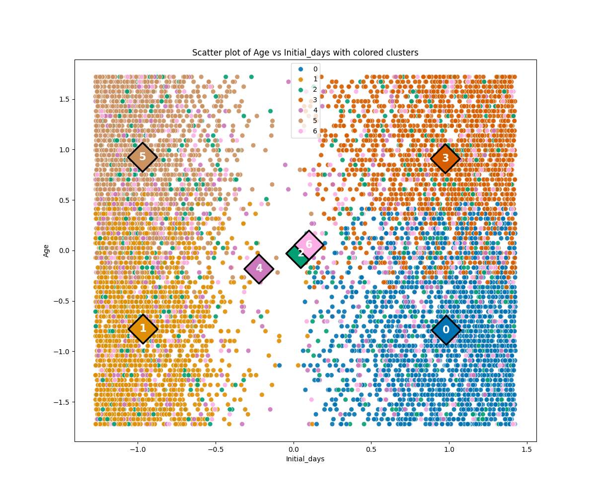

This model has a high inertia of ~89000 and a poor silhouette score of 0.098 with 7 clusters. The WCSS vs number of clusters curve lacks a decent inflection point to use the elbow method. If the silhouette score’s preference of two clusters were used, the model’s silhouette score would be ~0.145 at the expense of an inertia of ~112000.

Reviewing the centroids, ‘Doc_visits’, ‘Full_meals_eaten’, ‘vitD_supp’, and ‘VitD_levels’ all have low variance compared to the other variables. The values for ‘TotalCharge’ closely follow those for ‘Initial_days’, and from previous work it was determined that these two variables have a very strong correlation, so a refined model will remove ‘Doc_visits’, ‘Full_meals_eaten’, ‘vitD_supp’, ‘VitD_levels’, and ‘TotalCharge’.

cluster_columns_1a = ['Initial_days', 'Age', 'Children', 'Income', 'Additional_charges', 'Population', 'Lat', 'Lng']

Output:

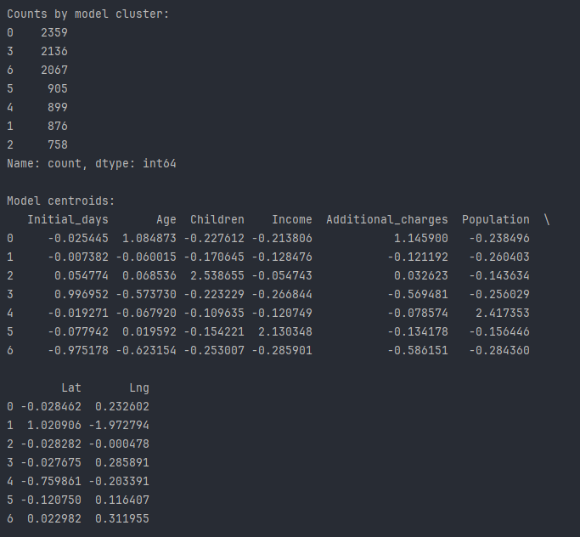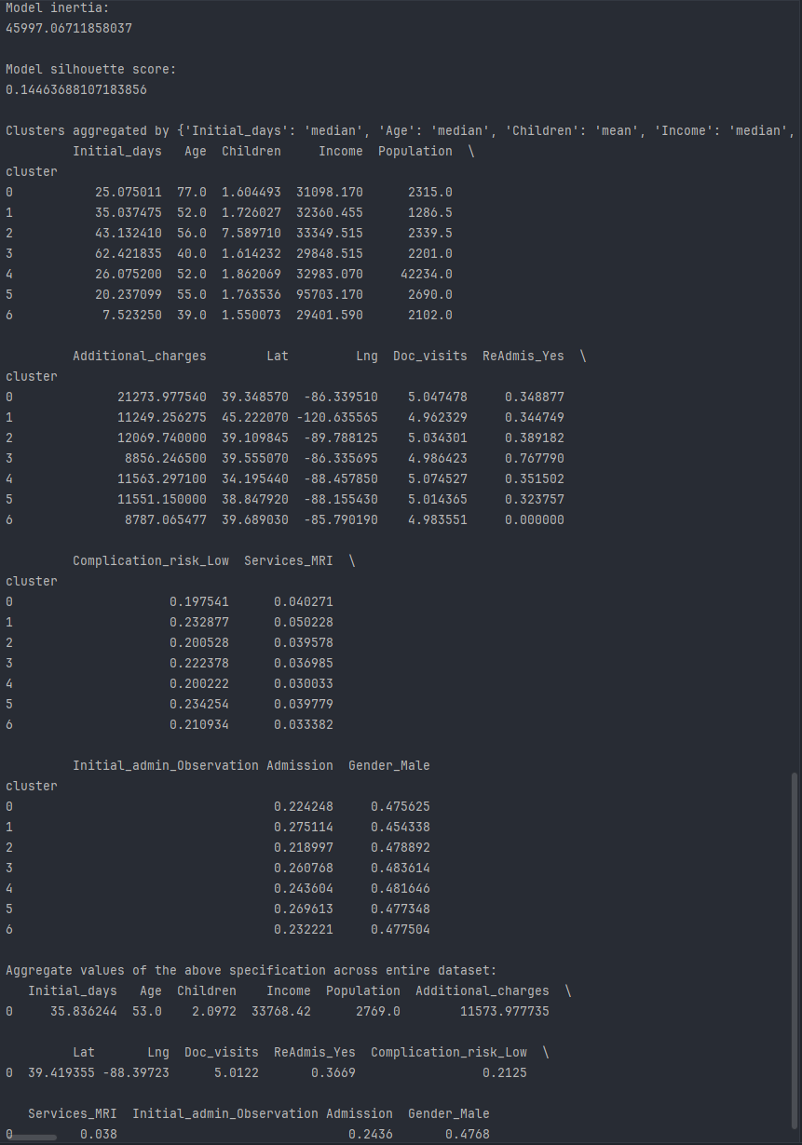

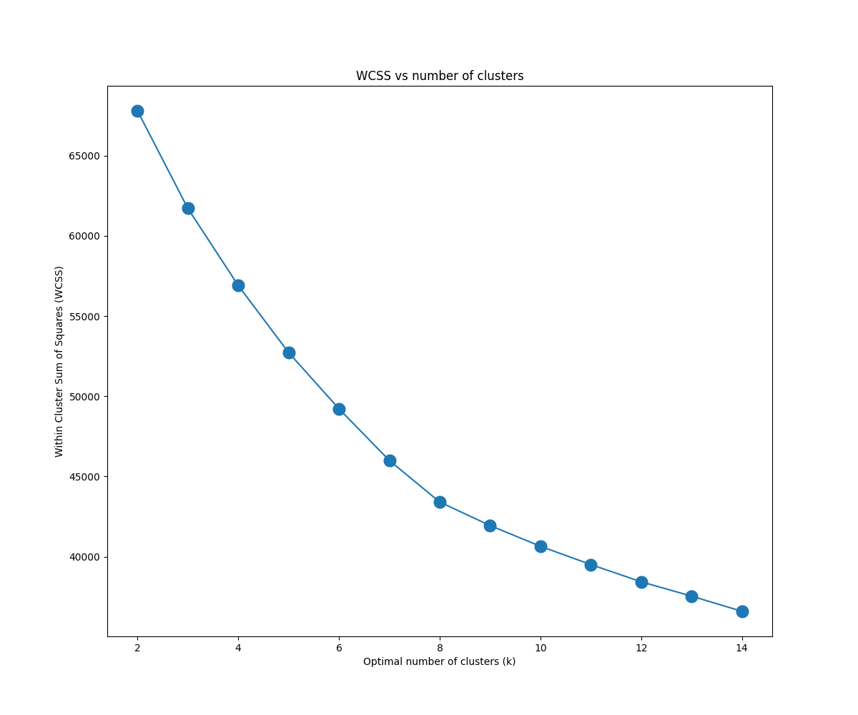

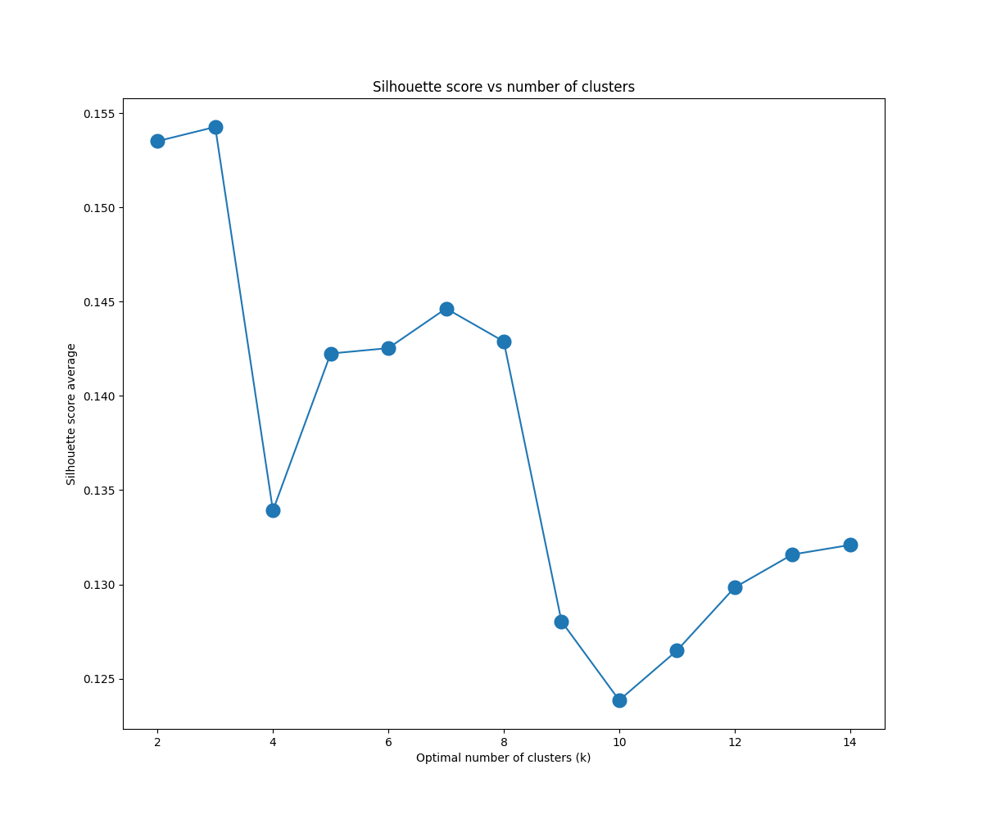

The inertia has been reduced to ~46000 and n_clusters = 7 balances the inertia (WCSS) with the silhouette score of 0.145. Below are some of the more relevant clustered scatter plots involving ‘Lat’ and ‘Lng’:

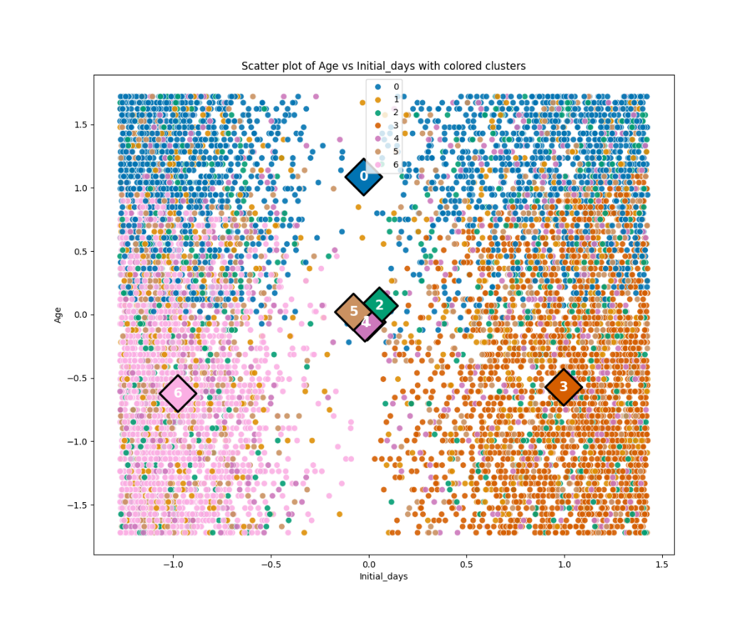

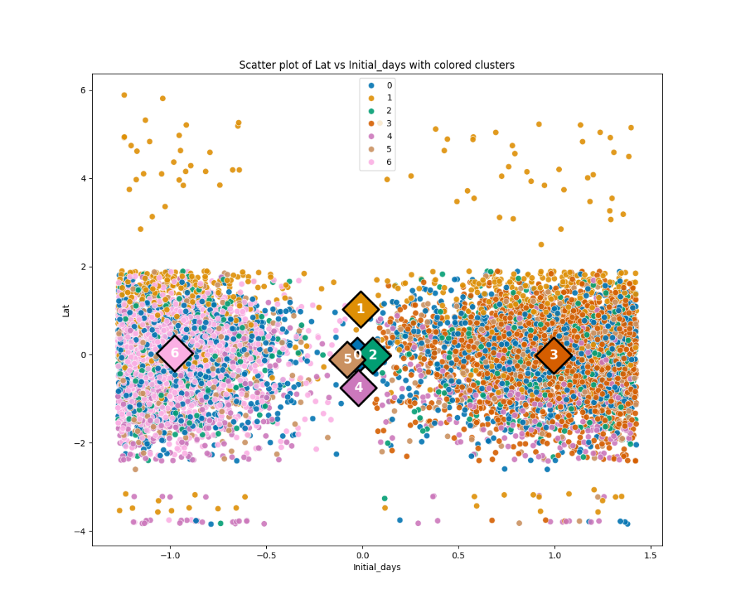

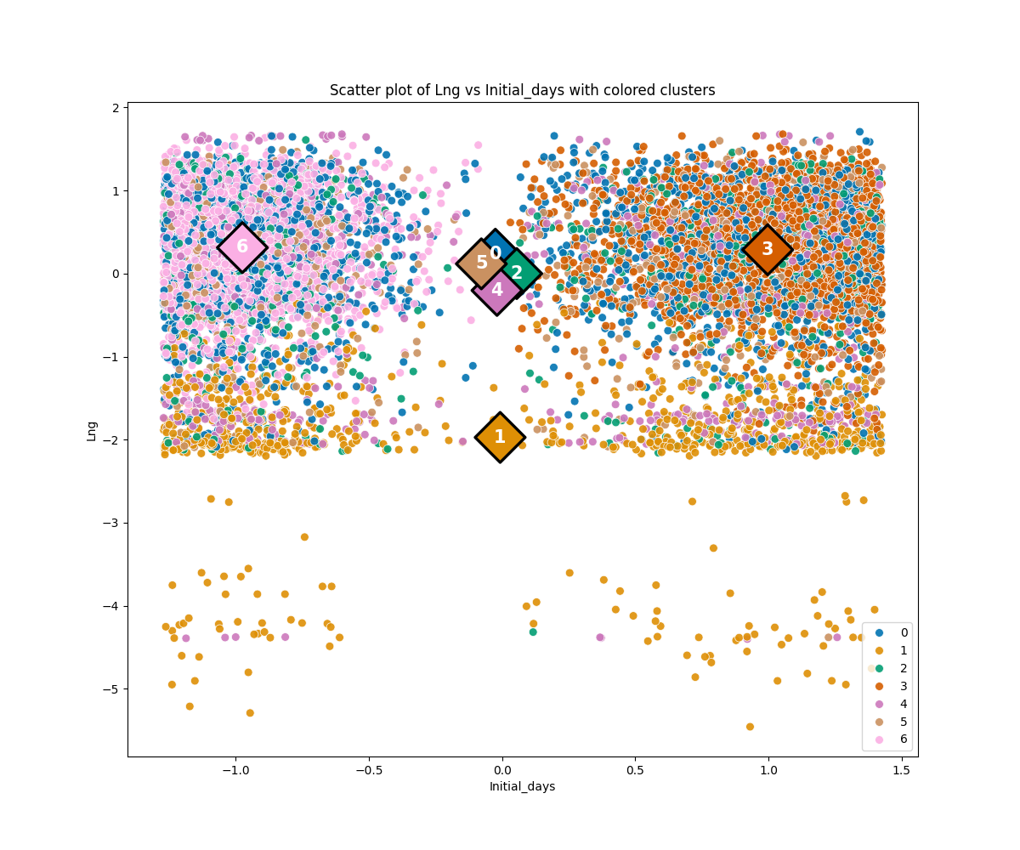

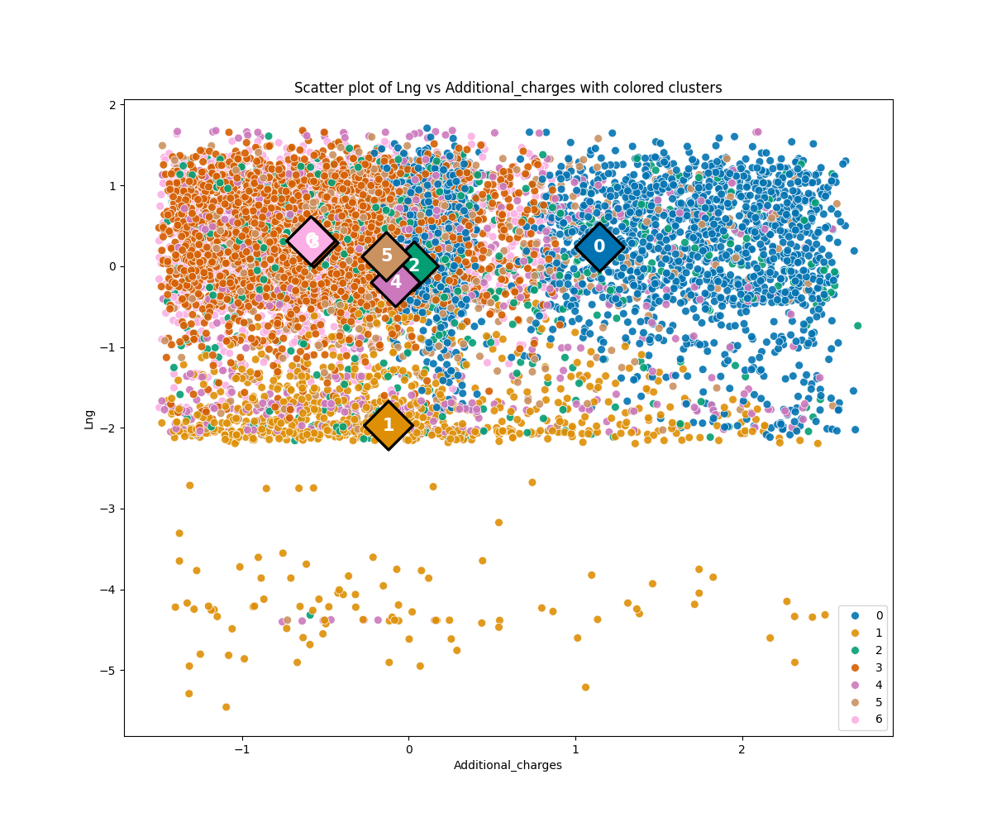

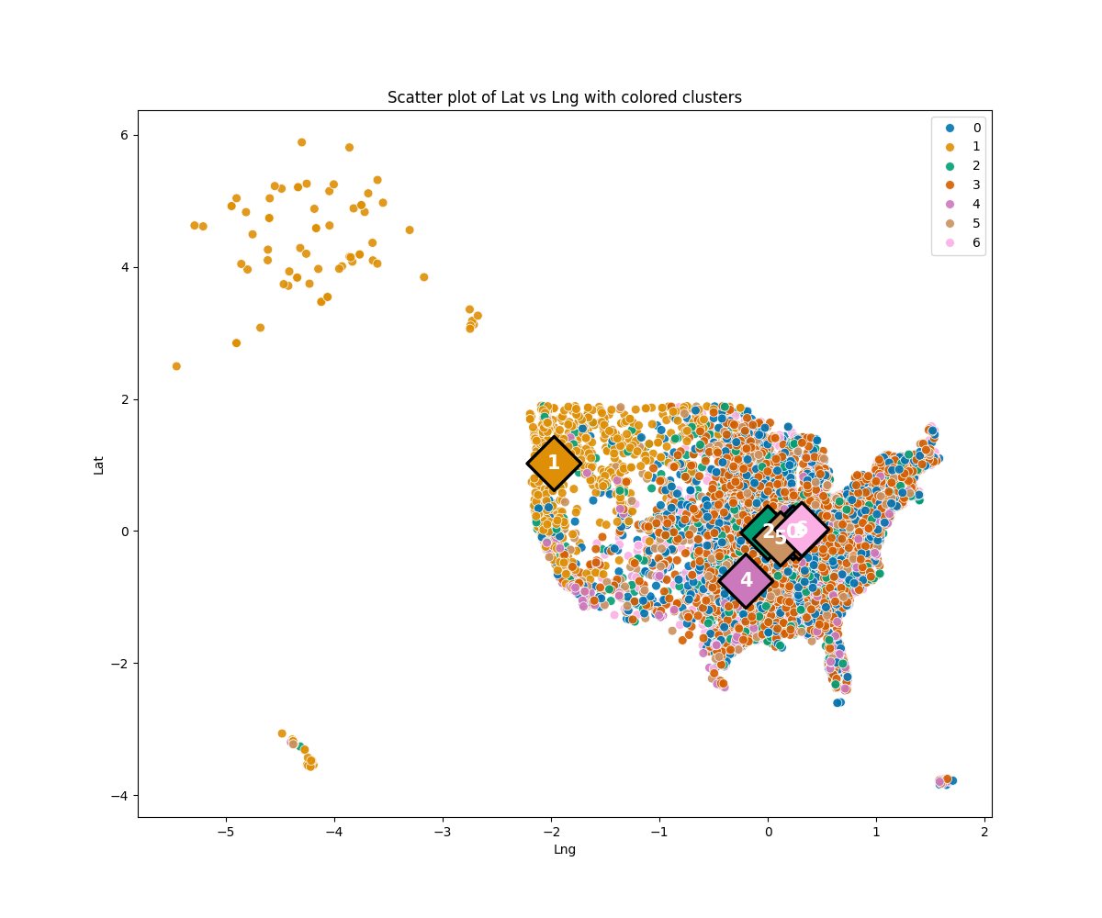

Looking over these plots, five of the seven clusters are practically overlapping in a part of the U.S. that’s slightly east of the geographic center. Given the increased populations in the eastern part of the country, this is to be expected, and is corroborated by the median values of ‘Lat’ and ‘Lng’ across the entire dataset. Cluster 4 is located slightly southwest. Of greatest note is cluster 1 centered in the Pacific Northwest to accommodate Alaska and Hawaii. The provided cluster plots show cluster 1 generally being centered close to 0 on most features. There are indicators of possibly statistically relevant differences in cluster 1 such as lower median populations and number of children, but the differences are still relatively small. ‘Lat’ and ‘Lng’ could probably be removed, so trying a new model with them removed:

cluster_columns_2 = ['Initial_days', 'Age', 'Children', 'Income', 'Additional_charges', 'Population']

Output:

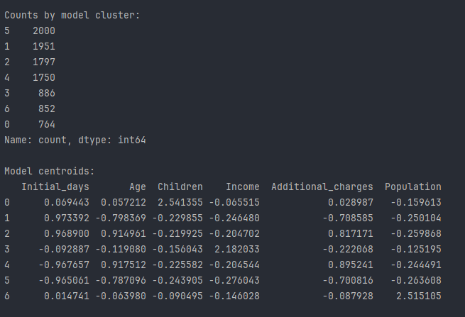

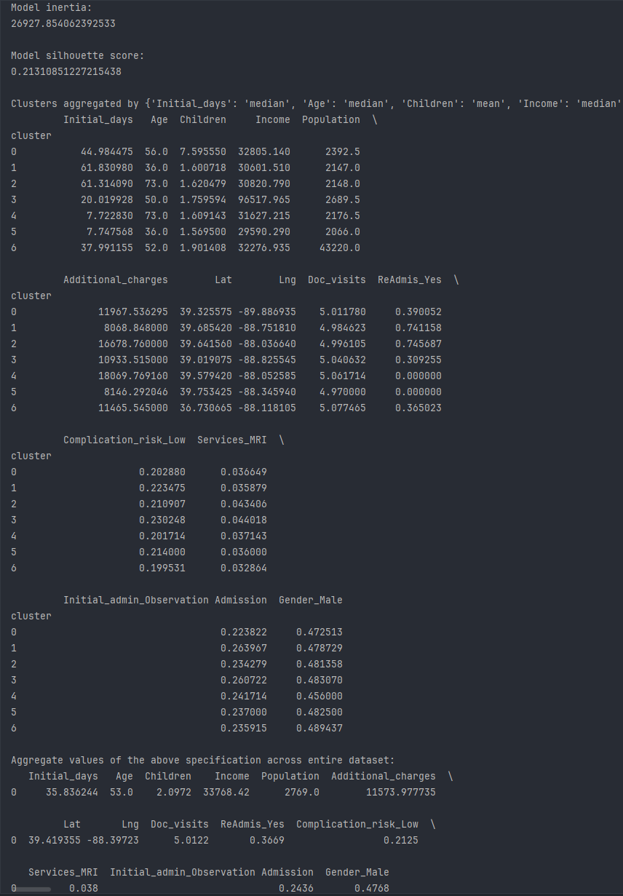

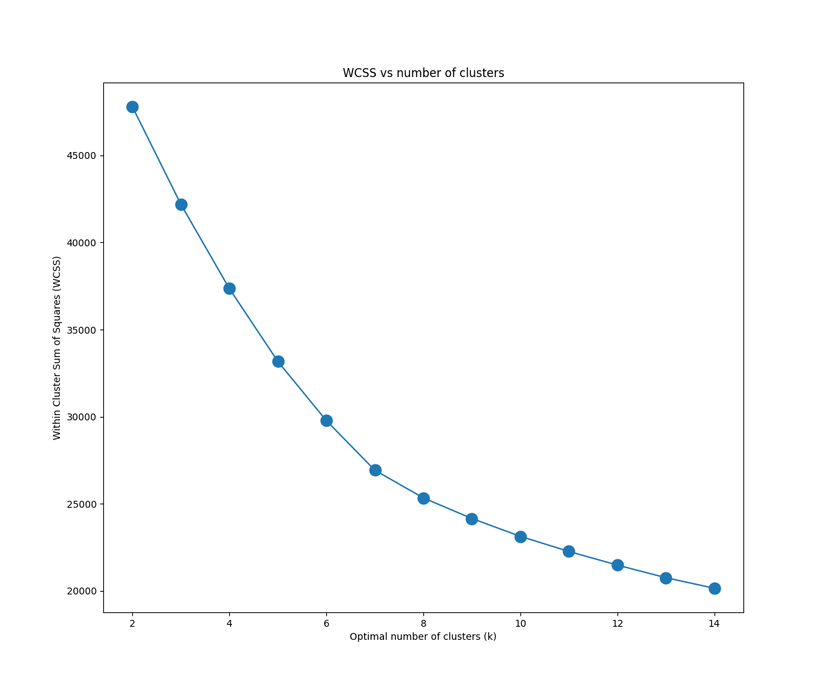

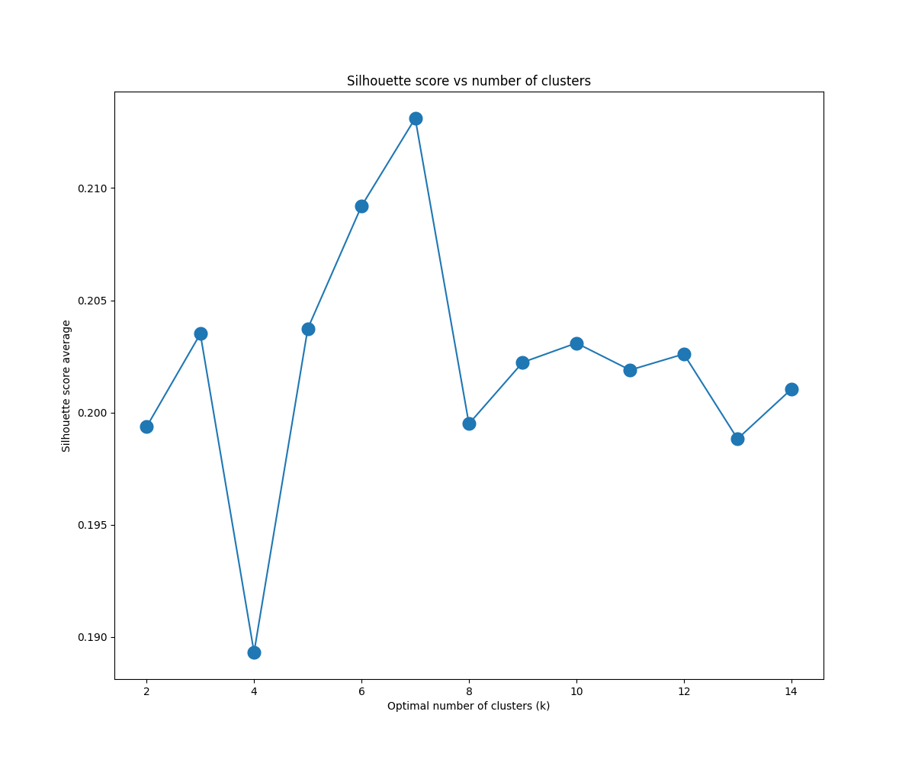

See section E.1. for the cluster scatter plots of various variables.

This refined model’s inertia has been substantially reduced to ~27000 with a silhouette score of 0.213. There is substantial variation in all six features across centroid coordinates, indicating they’re all relevant to the determined clusters.

To determine the optimal number of clusters, the “elbow method” can be used to find a point in the WCSS curve where the inertia begins to decrease more slowly (as trying to minimize the inertia absolutely would select a number of clusters too high to be of practical use). A potential “elbow” occurs at n_clusters = 7 in the inertia plot, although the curve is rather smooth and makes this decision ambiguous. Tomar (2023, [2]) discusses such a pitfall and recommends using the silhouette score. The silhouette score for a given point is calculated as the difference between the average inter-cluster distance and the average intra-cluster distance divided by the maximum of the two. The silhouette score for the model is then calculated as the mean of the silhouette scores (across all points in the dataset). The silhouette score ranges from -1 to +1, with +1 indicating points are well assigned to easily distinguished clusters, 0 implies overlapping clusters, and -1 indicates points are incorrectly assigned.

The plot of silhouette scores by number of clusters used in the model shows an optimal value occurs at n_clusters = 7, which was used in this model and its above output.

Between the “weak” point of diminishing returns in the inertia curve (using the “elbow method”) and the optimal number of clusters determined by silhouette score, the ideal number of clusters for this final *k*-means clustering model is n_clusters = 7.

**D.2. Code execution**

See the attached file “clustering.py”. Screenshots are included below.

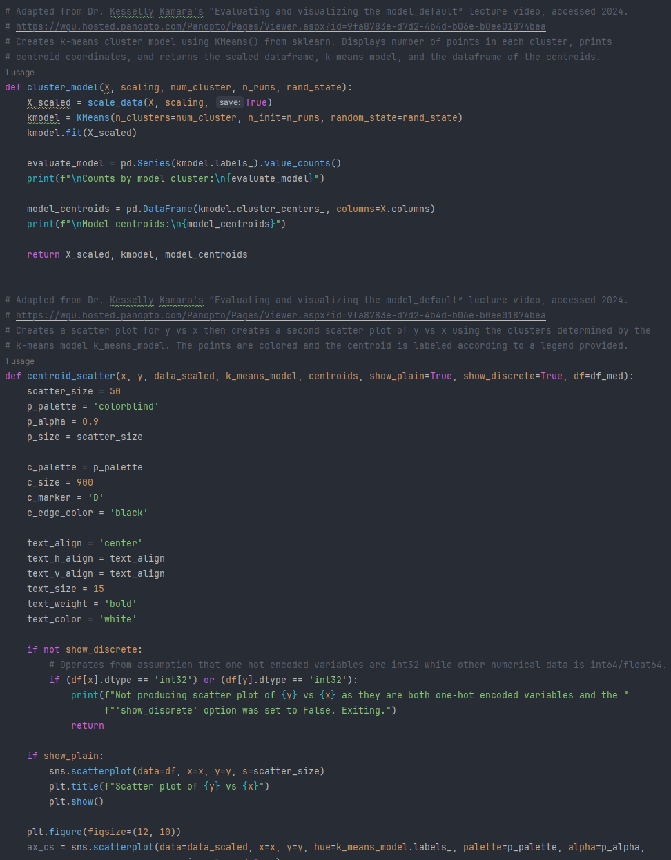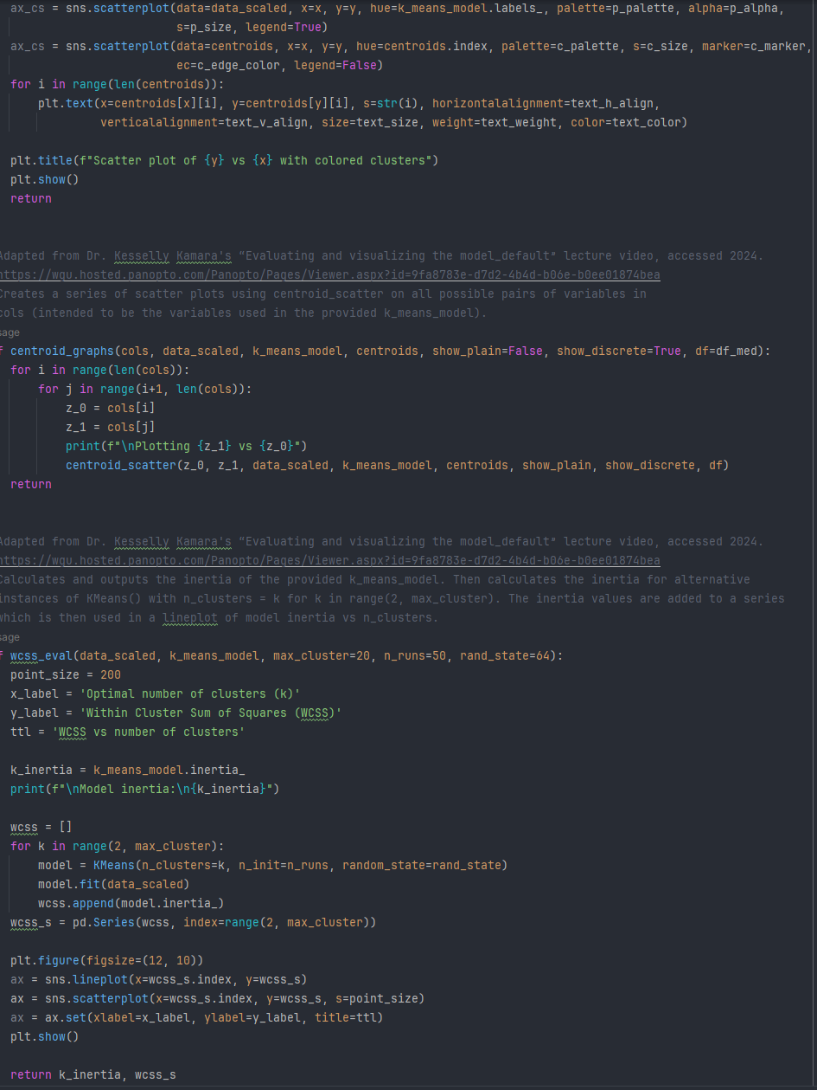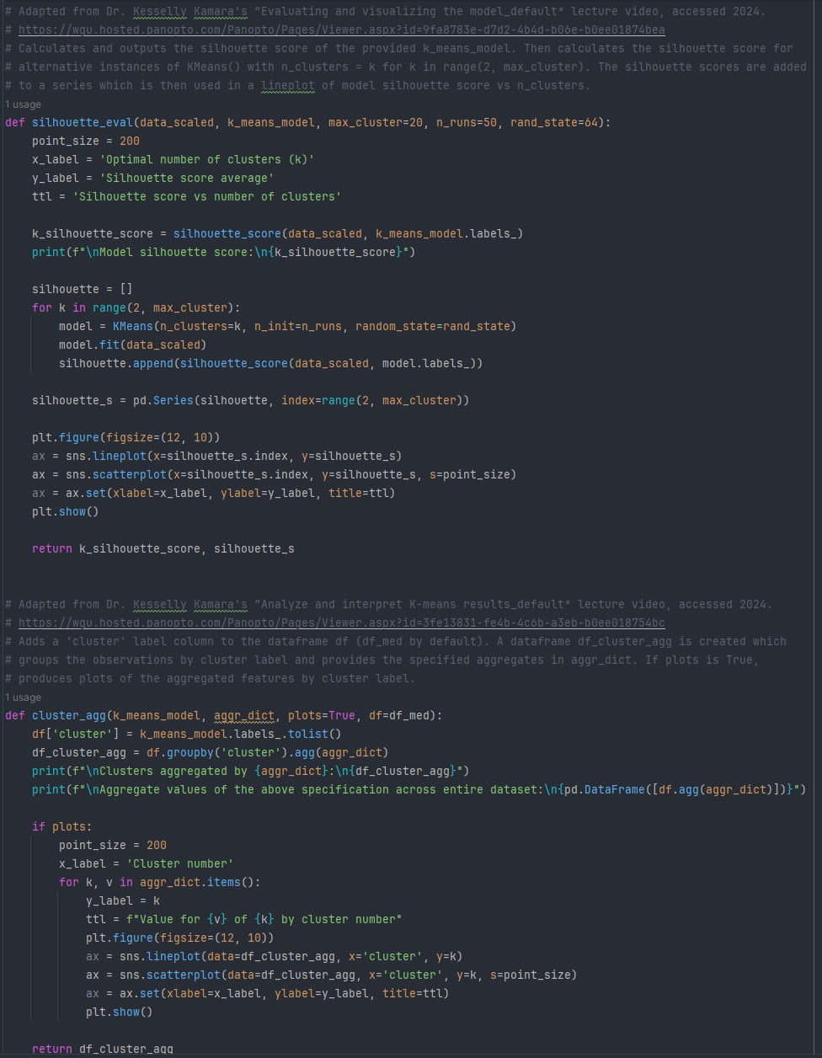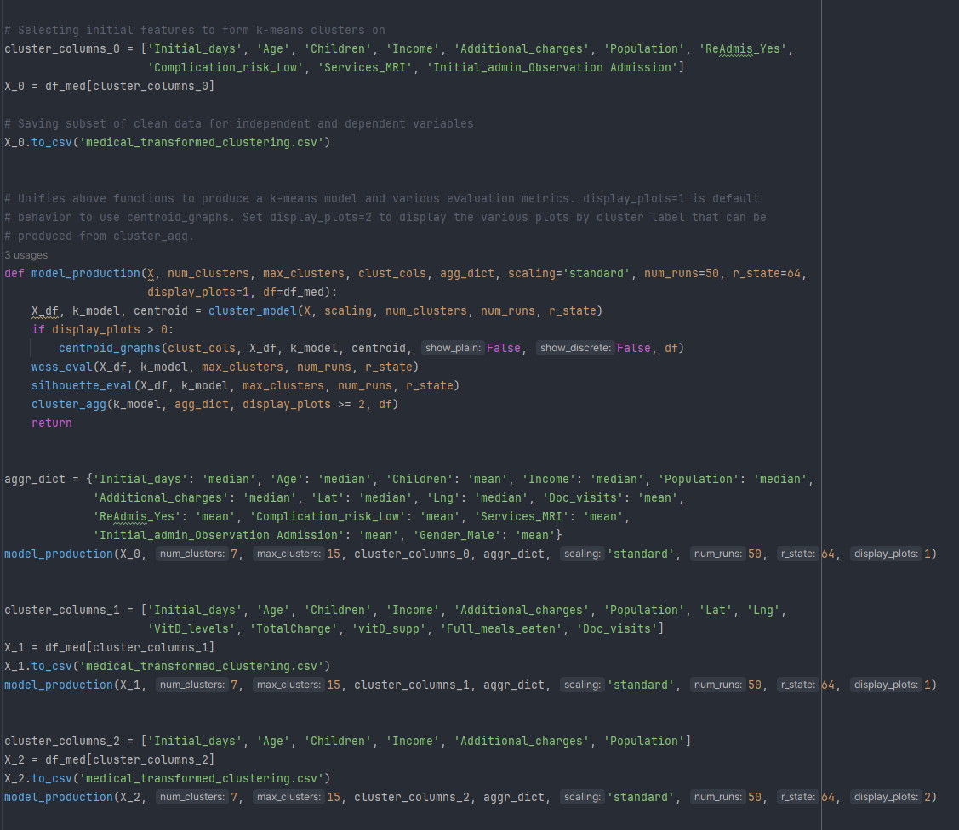

**E.1. Quality of the clustering technique**

A *k*-means cluster model is generally evaluated by its inertia, silhouette score, relevance of features as assessed by centroid locations across all dimensions (variables), the relative sizes of the clusters, and if applicable a comparison with expected labels such as species withheld from the algorithm (in this project there are no previous labels to assess accuracy with). Discussion of the properties of individual clusters, as well as scatter plots of the clusters, is in section E.2.

For a set of *k* clusters *Ci*,the inertia can be written as:

$$WCSS=\underset{C}{\arg{min}}{\sum_{i=1}^{k}{\left|C_{i}\right| Var C_{i}}}$$

taking the $\{C_{i}\}$ that minimize the summation. This can be viewed as a weighted sum of the intra-cluster variances. A weighted mean variance could be computed as WCSS/*N* for a dataset with *N* points. If the variance between each of the *d* dimensions is of approximately the same scale, a second quantity could be calculated as WCSS/(*Nd*), which is a rough measure of the average variance per dimension (squared distance from the centroid to a point along each of the *d* axes). The square root of this then gives a scale of the distance from a centroid to one of its points along the *d* dimensions.

In the final model, $N=10000$, $d=6$, and the inertia was $\text{WCSS}=26927.85$, giving $\sqrt{\frac{\text{26928}}{60000}}≈0.670$. The data was scaled to a standard normal distribution with variance 1, so broadly speaking for the entire dataset, points within clusters are 0.67 standard deviations (which was normalized to 1) away from their centroids along each of the six dimensions.

As the plots in section E.2. demonstrate, this is an approximation that doesn’t always hold for all clusters and all dimensions, yet is sufficiently close to be a good numerical measure of dispersion (radii) of the clusters.

A more common evaluation metric of cluster quality is the silhouette score discussed in section D.1, varying between -1 and +1 where +1 is optimal and 0 indicates overlap. The final model’s silhouette score with 7 clusters is 0.213. Far from ideal although not meaningless nor inconsequential. Some clusters do have considerable overlap along certain dimensions, explaining the subpar silhouette score. Still, there are many notable distinctions between the clusters that demonstrate their relevance, which will be discussed in the following section, along with a comparison of cluster sizes and feature relevance.

**E.2. Results and implications**

The model had the following results:









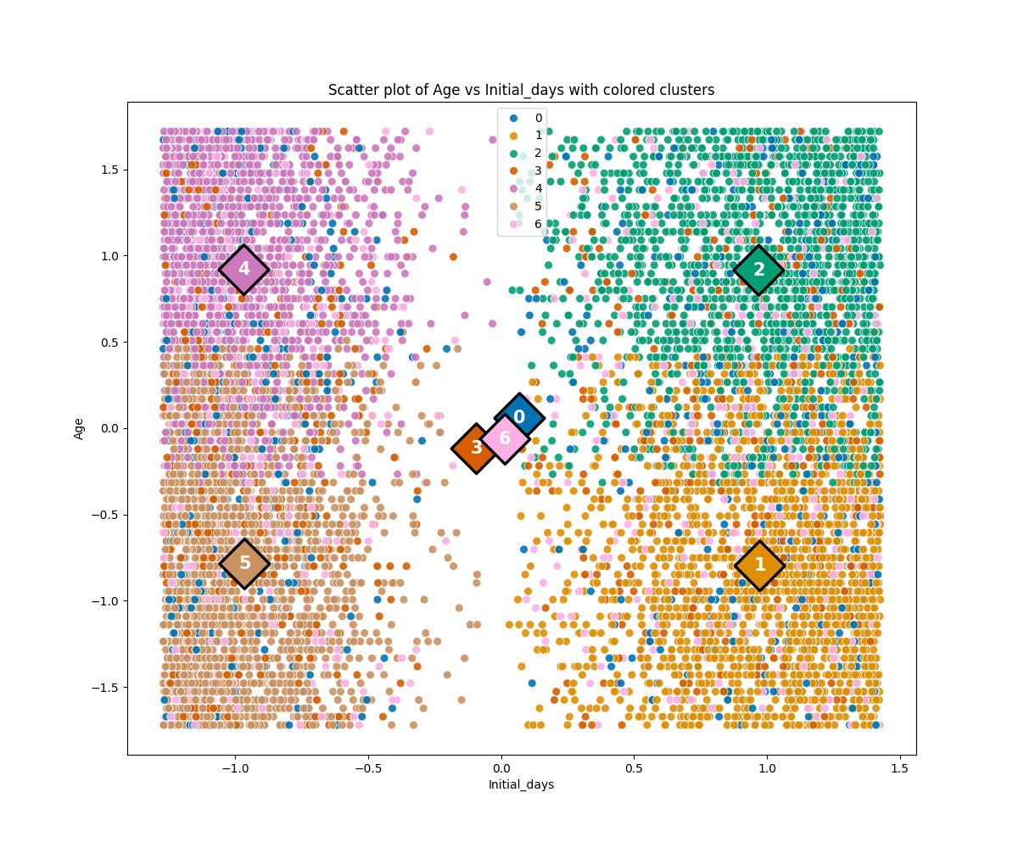

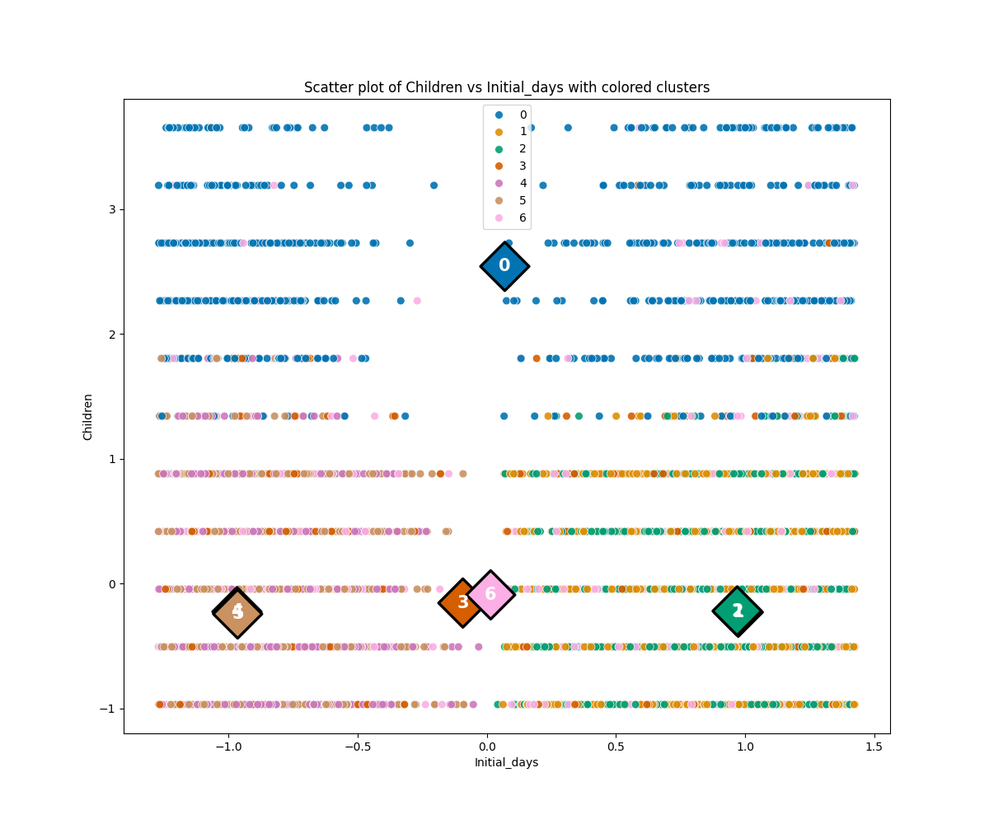

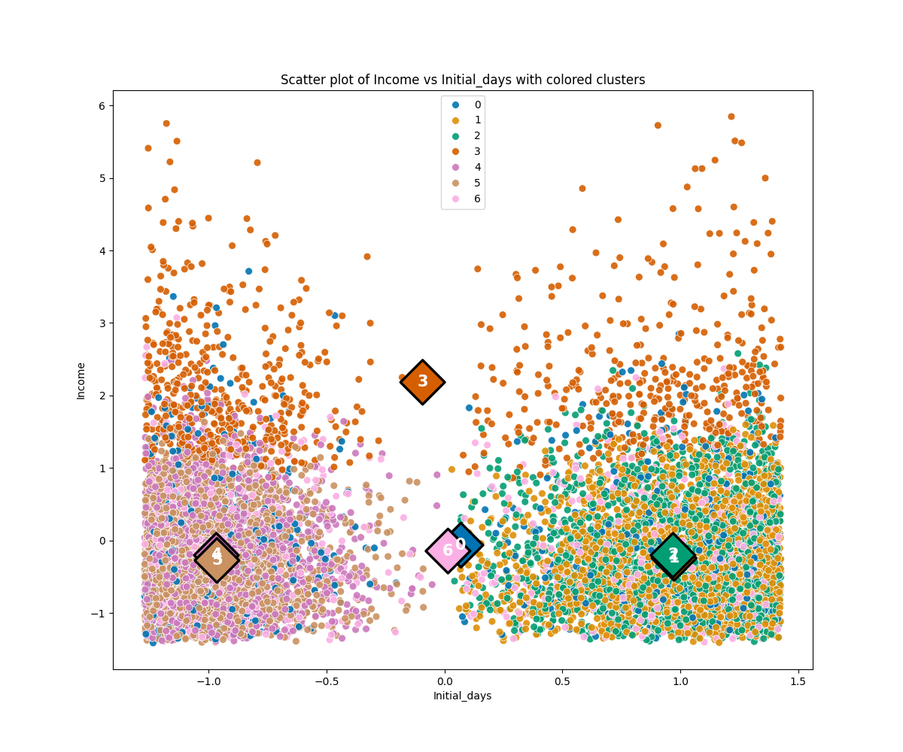

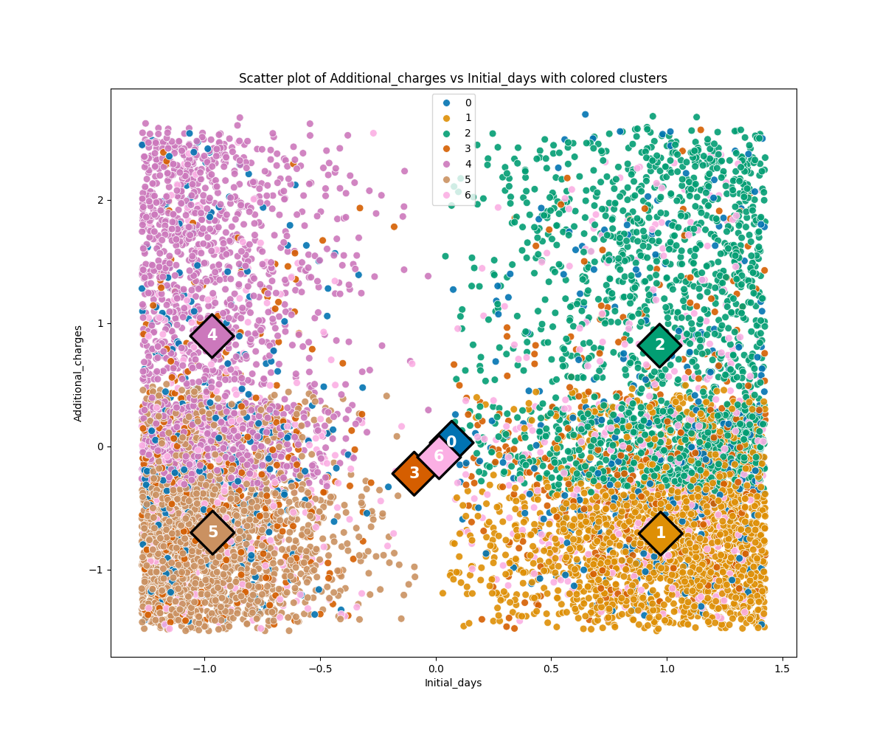

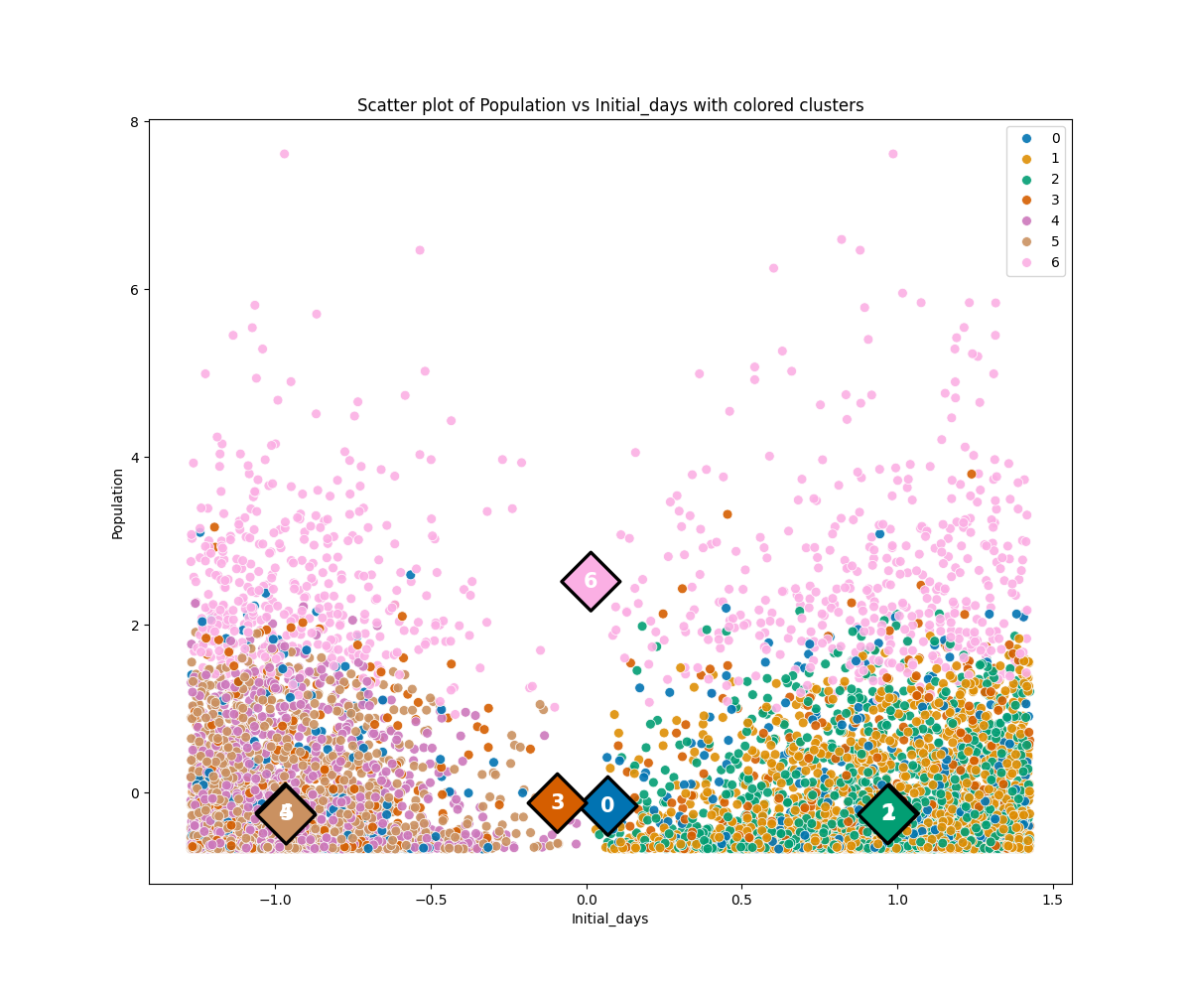

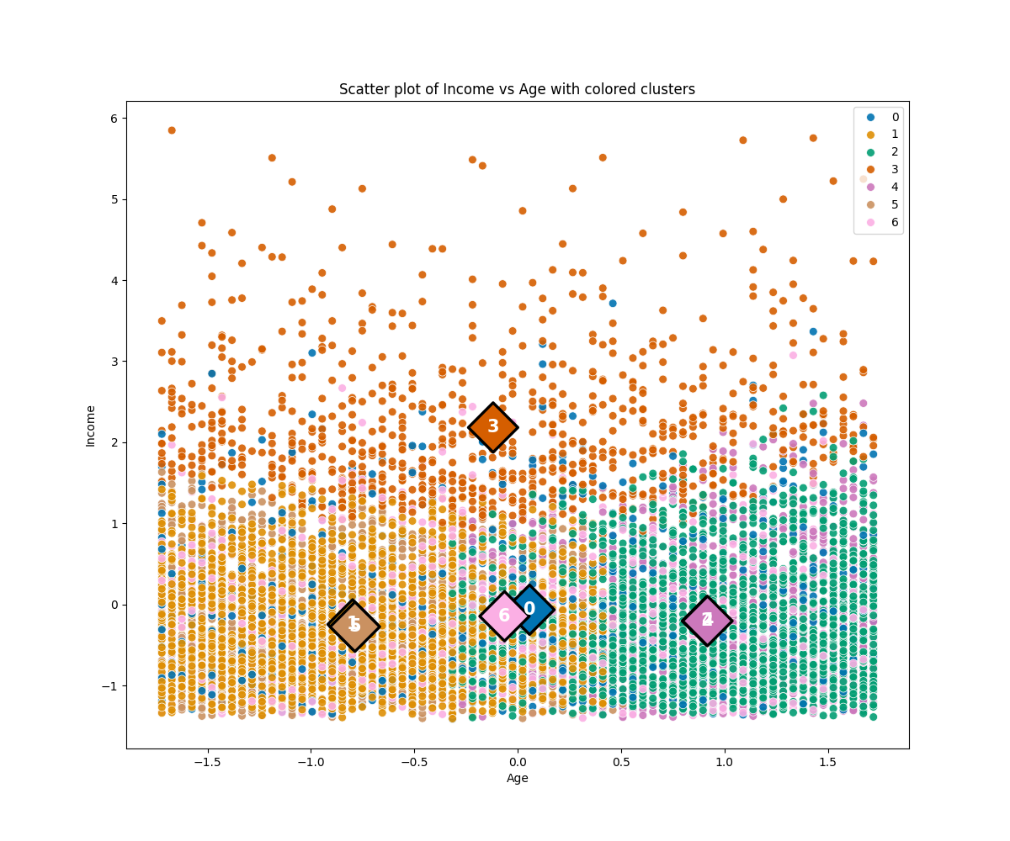

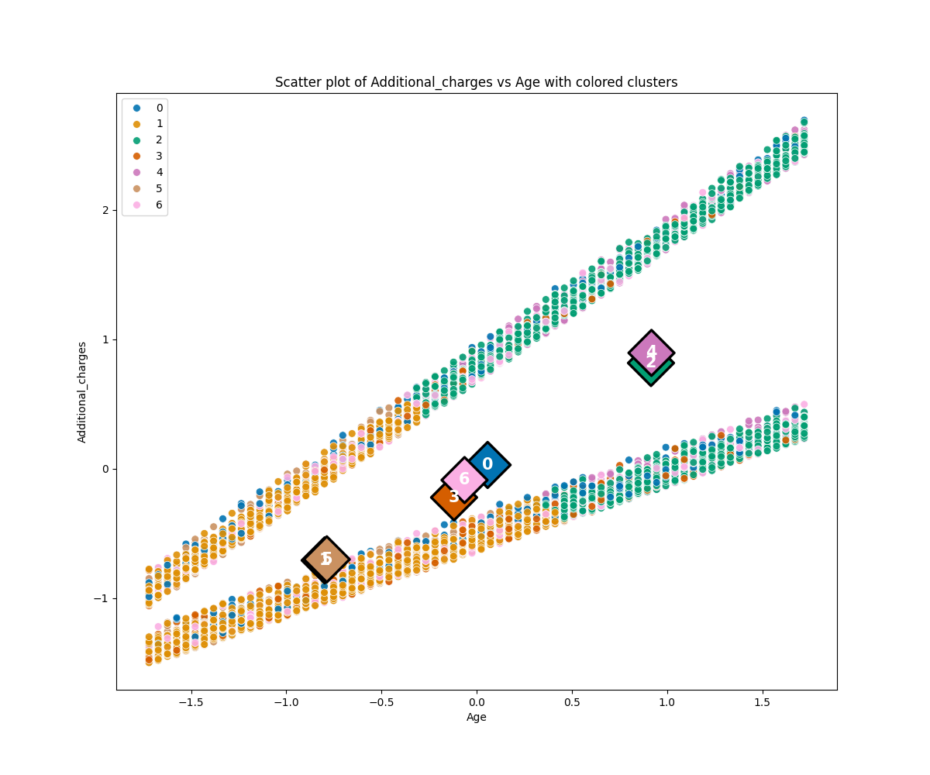

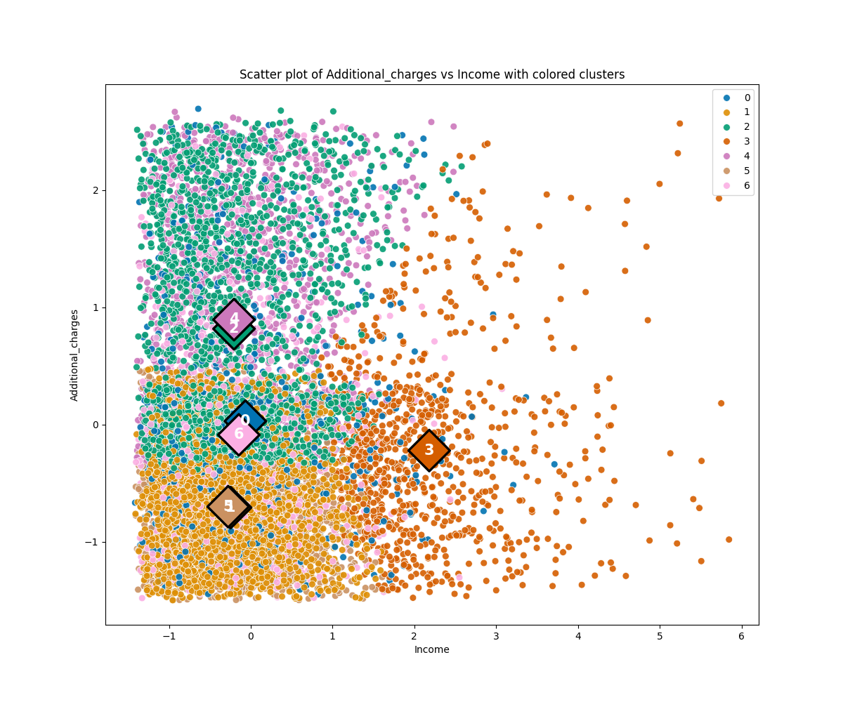

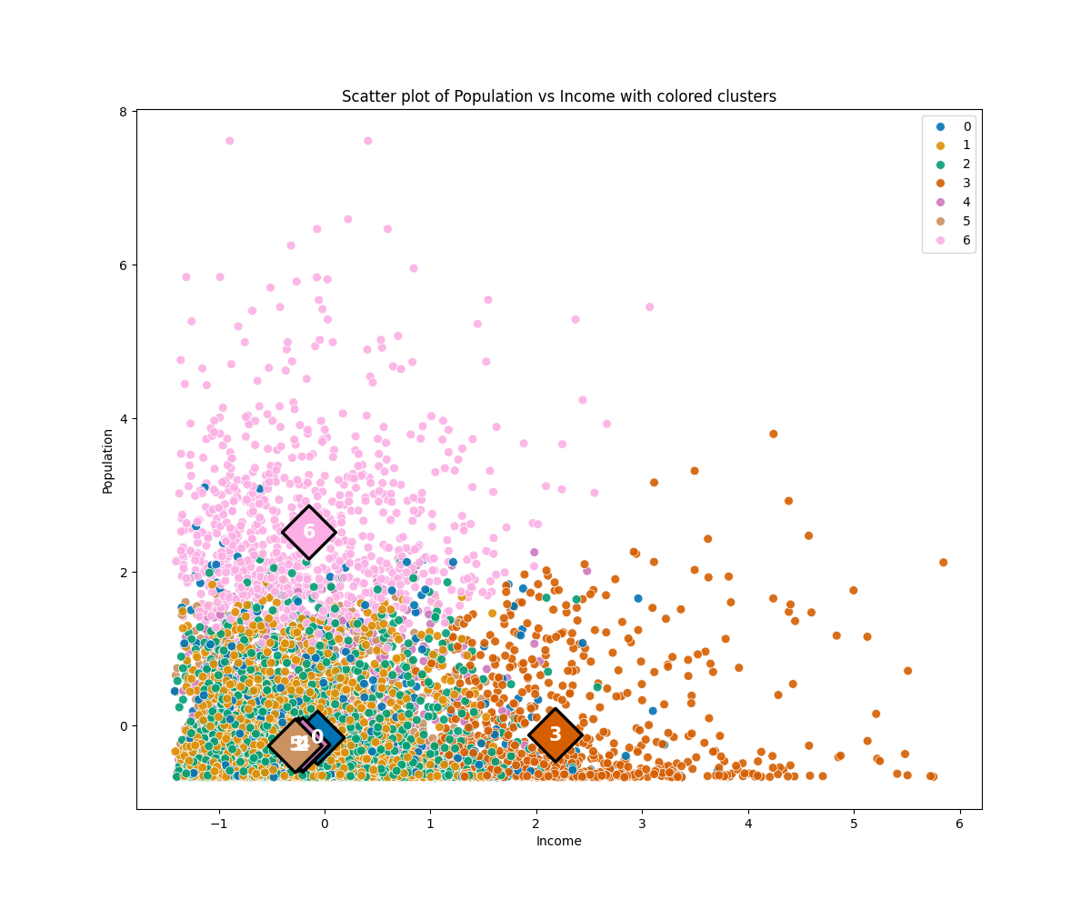

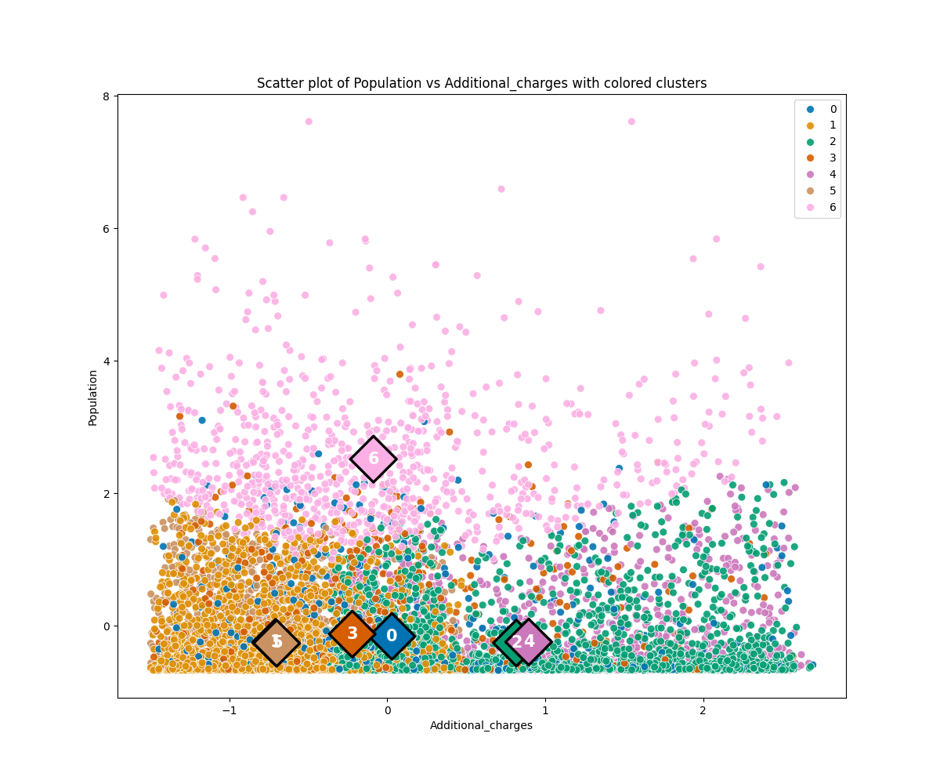

The model has an inertia of 26927.85 and a silhouette score of 0.213, with their relevance and implications discussed in the previous section. Cluster sizes range from 764 to 2000, which is a reasonable scale. Centroid coordinates have significant variation among all dimensions in at least one cluster, demonstrating the relevance of all six features to the cluster formation.

Beginning with the first scatter plot ‘Age’ vs ‘Initial_days’, four clusters (1, 2, 4, and 5) are formed among the four corners of the variables’ ranges while the other three (0, 3, and 6) have centroids approximately in the middle with points scattered throughout. Although no overlap would be ideal, across six variables with 15 different pairs and associated 2D scatter plots, it’s expected that some pairs of variables will have overlapping clusters.

The plot of ‘Children’ vs ‘Initial_days’ shows cluster 0 corresponding to patients with a large number of children. ‘Income’ vs ‘Initial_days’ shows high income in cluster 3 while ‘Population’ vs ‘Initial_days’ finds high populations in cluster 6. Returning to ‘Age’ vs ‘Initial_days’, cluster 5 consists of young patients with a short initial stay, cluster 1 is young patients with a long initial stay, cluster 4 is older patients with a short initial stay, and cluster 2 is older patients with a long initial stay.

A more precise comparison can be done by reviewing the aggregate results for the clusters and how they compare to overall means and medians throughout the entire dataset.

Cluster 0 has a mean number of children of 7.60 compared to the overall mean of 2.10, clearly corresponding to patients with several children. Many of the differences across the remaining selected aggregated variables are fairly small, but it’s worth noting that these patients have an initial stay of 45.0 days compared to the median value of 35.8, skew towards being slightly older and in less populated areas, a slightly higher incidence of readmission, and a slightly lower incidence of being admitted of observation.

Cluster 1 is informally “young patients with long stays”, an average number of children of 1.60, incomes and populations somewhat lower than overall averages, considerably reduced median additional charges of $8069, and a readmission incidence of 74%.

Cluster 2 is informally “older patients with long stays”, having many similarities with cluster 1 (along the aggregates apart from age), although their additional charges are considerably higher at $16679. They also have slightly lower rates of observation admissions and low complication risks compared to cluster 1.

Cluster 3 primarily corresponds to patients with high income, having a median value of $96518. Their initial stays have a median of 20.0 compared to the overall of 35.8, slightly lower median age and mean number of children, populations very close to the overall median, and readmission rates of 30.9% compared to the overall rate of 36.7%.

Cluster 4 is informally “older patients with short stays”. They share many similarities with cluster 2 (excluding the initial stay length), although they oddly have higher additional charges of $18070. Incredibly, they have a 0% readmission rate as well as only 45.6% of these patients being male.

Cluster 5 is informally “younger patients with short stays”. Comparing to cluster 1, many values (other than length of stay) are similar, apart from a reduced rate in observation admissions and a 0% readmission rate.

Cluster 6 has a median population of 43220 in contrast to the overall median of 2769, clearly corresponding to patients living in dense urban areas. Many differences are small compared to overall averages, although these patients tend to have slightly longer initial stays of 38.0, fewer average children of 1.90, the highest number of doctor visits among any other cluster (although that difference is still quite small), and slightly lower rates of low complication risk, seeking MRIs initially, and being admitted for observation.

Among all clusters, the small differences in doctor visits and percentage of men show any relationship between gender or number of doctor visits is also rather small among the clusters.

Among the above findings, it’s insightful to find a 0% readmission rate in patients with short initial stays of any age (clusters 4 and 5), worthy of additional research. It’s also peculiar that additional charges increase so significantly on the basis of age, even for patients with short stays. Even more puzzling is why older patients with short stays have higher additional charges than those with long stays. All clusters have details worthy of additional analysis, although clusters 1, 2, 4, and 5 are of greatest relevance to analysts and administrators seeking to reduce readmission rates. Clusters 0, 3, and 6 may contain relationships of interest between their primary identifier (number of children, income, and population, respectively) and other features in the data, including but not limited to what was already mentioned.

**E.3. Limitation**

*k*-means clustering prioritizes minimizing distances between points and cluster centroids, inherently limiting its ability to capture irregular clusters, nor does it contain deeper insights into hierarchical or conditional relationships. Additionally, it lacks the ability to meaningfully cluster on encoded categorical variables (as discussed previously in section C.2.), which would require an alternative clustering method such as *k*-modes.

As the algorithm seeks to minimize inertia, heavily skewed distributions and outliers can distort the clusters selected by the algorithm, creating a cluster of outliers in one variable that has little relevance to relationships within the rest of the data. Its existence would primarily be to reduce the model’s inertia.

Overall, broader hierarchical and/or dependent relationships within the data or the clusters themselves may go unnoticed with *k*-means cluster models that simply assign points based on distances to centroids. In the event clusters overlap, there can be issues with interpretation in how those points should be assigned, and what if any differences exist between the clusters.

Although the model may be limited in its understanding, granular, ground-level knowledge from patients and medical staff can provide insight into relationships within their relevant cluster and comparisons to other clusters. As always, the limitations of the provided data (in its variables and types) limit what the model can demonstrate and conclude.

**E.4. Course of action**

The goal of this project was creating a *k*-means cluster model that finds meaningful clusters of patients while also identifying the least and most relevant variables in the creation of those clusters. From the results described in section E.2., in the interest of deeper understanding of factors affecting patient readmission rates, it’s recommended to perform additional analysis and data collection of patients in clusters 5, 4, 1, and 2, corresponding to short vs initial stays and young vs old age groups, respectively. Further, there is an unexpected discrepancy in additional charges facing elderly patients who have short rather than long initial stays worthy of follow up. There’s a stark difference in additional charges between age groups that should also be investigated in the event it can’t be explained as age-related complications and health expenses. High-income patients have a noticeable reduction in their initial stays compared to the overall median and a reduced readmission rate. Investigating this difference, whether it’s better overall health of these patients prior to admission or some degree of discrimination on the part of the hospitals, would serve patient equity.

**F. Panopto video of code**

See the attached link: https://wgu.hosted.panopto.com/Panopto/Pages/Viewer.aspx?id=e4121325-a814-42a5-846f-b17b011fa06c

**G. Sources for third-party code**

**1.** WGU. 2024. D212 Data Mining II “Data Sets and Associated Data Dictionaries”. Medical Data and Dictionary Files. Retrieved May 23, 2024, from <https://access.wgu.edu/ASP3/aap/content/jf8rcds032ldktfces9r.html>.

**2.** Kamara, Kesselly. 2024. WGU D212 “Evaluating and visualizing the model_default”. Retrieved May 23, 2024, from https://wgu.hosted.panopto.com/Panopto/Pages/Viewer.aspx?id=9fa8783e-d7d2-4b4d-b06e-b0ee01874bea.

**3.** Kamara, Kesselly. 2024. WGU D212 “Analyze and interpret K-means results_default”. Retrieved May 23, 2024, from https://wgu.hosted.panopto.com/Panopto/Pages/Viewer.aspx?id=3fe13831-fe4b-4c6b-a3eb-b0ee018754bc.

**H. Sources**

**1.** Sharma, Pulkit. 2024. “The Ultimate Guide to K-Means Clustering: Definition, Methods and Applications”. Retrieved May 24, 2024 from <https://www.analyticsvidhya.com/blog/2019/08/comprehensive-guide-k-means-clustering/>.

**2.** Tomar, Anmol. 2023. “Stop Using Elbow Method in K-Means Clustering”. Retrieved May 24, 2024 from https://builtin.com/data-science/elbow-method.